Religious Education and Worldviews
Knowledge Organiser to support the Norfolk Agreed Syllabus
Year Group: 4
Enquiry: 4
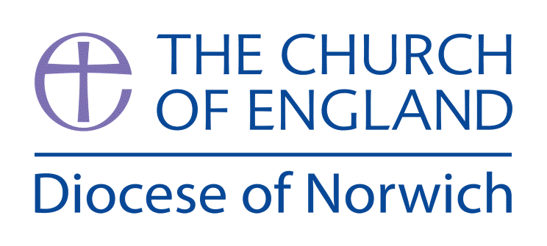

Why is there so much diversity of belief within Christianity?

(Intention) What we intend to cover in our learning: (Topic web of concepts here)

Sessions 1 and 2: Play a game of ‘Broken Telephone’ with the children. What do they believe the original message was? Use this as a discussion starter into believing what we are told by others. If we only have one source of information how do we know the truth?
Watch the video about Martin Luther https://www.youtube.com/watch?v=FhGGjRjvq7w
He wanted to make sure that everyone had the opportunity to read the Bible for themselves. It is a source of authority for Christians. If everyone is able to read the Bible today, why do Christian churches, worship, rites of passage and festivals have diversity?

Engage

Session 3: Introduce the ‘Big Question’. Collect questions that they have (KWL Chart) to look at again in Evaluate part. Using the ‘Knowledge’ part of the chart, add to the ‘Wonder Wall’ - display their questions and add knowledge through the Enquire and Explore lessons.

Enquire and Explore

Session 4: Jesus gave the Great Commission (Matthew 28:16-20) and the disciples started the spread of his message across the world. Today there are 2.382 billion Christians in the world. The expression of Christianity has been affected by history, culture, society and tradition. One place to find evidence of Christians expressing their belief is in a church. What do the children know about church? What would they expect to see there? What would they expect to find there? Design a set of questions in advance of church visits that will help children be able to describe some of the varying ways in which Christianity is practised locally.

Session 5: Arrange visits to at least 2 denominations of church in the local area. Identify similarities and differences. Children to explore and answer the set of questions so they are able to describe some of the varying ways in which Christianity is practised locally.

Session 6: Compare and contrast a festival, rite of passage or worship (e.g. communion) across two different denominations. Use the churches visited or online information.

Evaluate
Session 7: Children to return to their questions on the ‘Wonder Wall’. Have they all been answered? Ask them to consider what a ‘typical’ Christian looks like. Does the diversity matter?

Express
Session 8: Write an Information text. Children to express an understanding of the basics of Christian belief. Children to describe some of the varying ways in which religions and beliefs are practised locally and nationally, giving examples from at least two denominations.

(Implementation) Key words I will use and need to know:

Christianity Belief Denomination
Practise Reformation Religion

Worship Society

(Implementation) Key information we will learn:
- Understand the Church as a global community of Christian believers.
- Awareness of the concept of denominations within Christianity, along with examples e.g. Anglican, Roman Catholic, Baptist, Methodist, Free Church, Salvation Army.
- Describe different expressions of Christian worship including for example the Eucharist and pilgrimage.
- The diverse ways in which people celebrate festivals such as Christmas, Easter and Pentecost; in particular contrasting two different contexts such as local/global or rural/urban.
- Identify a key event which influenced Christianity e.g. Martin Luther and the Reformation

(Implementation) Things to do and find out at home:

Explore how many Christians are in different countries around the world. Click on a country and look up the different percentages:

Operation World https://operationworld.org/prayer-resources/countries-alphabetically/

What can you find out about the local churches in your area? Do they have websites?

What do Christians believe?

http://www.primaryhomeworkhelp.co.uk/religion/christian.htm

(Implementation) Some key information you can find more out about:
- Awareness of the concept of denominations within Christianity https://www.bbc.co.uk/bitesize/guides/zbj48mn/revision/8
- Describe different expressions of Christian worship
https://www.youtube.com/watch?v=E5-aKSrLXM4&list=PLcvEcrsF_9zLNjB-h9xjVlhgG8f0fjk-9&index=5
- The diverse ways in which people celebrate festivals
Christmas - https://www.youtube.com/watch?v=IO6hjEjPxoM&list=PLcvEcrsF_9zLNjB-h9xjVlhgG8f0fjk-9&index=9
Easter - https://www.youtube.com/watch?v=MK2o-mhBfuc&list=PLcvEcrsF_9zLNjB-h9xjVlhgG8f0fjk-9&index=3
- Identify a key event which influenced Christianity e.g. Martin Luther
https://www.youtube.com/watch?v=FhGGjRjvq7w

(Impact) What we will aim to do at the end of our learning:
By the end of our learning we will:

- Describe the difference between the terms ‘religion’ and ‘belief’.

- Describe some of the varying ways in which Christianity is practised locally, nationally and globally.

- Identify events in history which have influenced Christianity e.g. Martin Luther and the Reformation.

(Impact) The RE Age Related Expectations we will cover and be assessed against:
Human and Social Sciences
- The diverse nature of religion Describe the difference between the terms ‘religion’ and ’belief’ when exploring religions, beliefs and worldviews.
- Diverse ways in which people practice and express beliefs Describe some of the varying ways in which religions and beliefs are practised locally and nationally (both within and between religions/worldviews) with reference to at least two religions/worldviews.
Theology
B. How beliefs change over time
Identify events in history and society, which have influenced some religious and non- religious worldviews.

Supplementary Ideas:

Helpful Key information and Resources:

Faith: What does it mean to be a Christian? http://request.org.uk/life/meet-a-christian/meet-a-christian/#

Martin Luther: A Fun, Animated History of the Reformation and the Man Who Started It All https://www.youtube.com/watch?v=FhGGjRjvq7w

Bible Translations http://request.org.uk/bible/questions-about-the-bible/why-do-we-need-different-translations/#

The Great Commission https://www.youtube.com/watch?v=26B_F_IluqA

Animated map shows how Christianity spread around the world https://www.youtube.com/watch?v=BJ0dZhHccfU

Church http://request.org.uk/life/church/#

Visit three types of churches http://request.org.uk/life/church/church-tours/#

Church: Denominations http://request.org.uk/life/church/denominations/

Depending on when this unit is taught one festival can be chosen. Look for opportunities to compare how this festival is celebrated in more than one church across your local town.

Christmas http://request.org.uk/festivals/christmas/christmas-in-church/

Easter http://request.org.uk/festivals/holy-week-and-easter/#

Rites of Passage: Baptism http://request.org.uk/?s=baptism#

https://www.youtube.com/watch?v=uRymbCJmbYk&list=PLcvEcrsF_9zLNjB-h9xjVlhgG8f0fjk-9&index=8

Worship – Holy Communion https://www.youtube.com/watch?v=fQq9WDliZGc&list=PLcvEcrsF_9zLNjB-h9xjVlhgG8f0fjk-9&index=4

