Religious Education and Worldviews
Knowledge Organiser to support the Norfolk Agreed Syllabus
Year Group: 4
Enquiry: 1
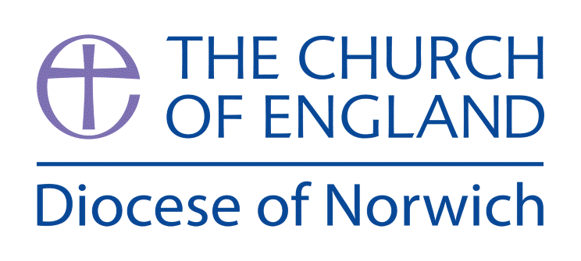

Where do Christian religious beliefs come from?

(Intention) What we intend to cover in our learning: (Topic web of concepts here)

Engage
Session 1: Give the children a selection of genres of reading e.g. map, instructions, poetry, stories, history, songs etc. Ask them to sort them into piles. Can they label their genre? Can they explain how they would be used. Introduce the BIG Question and explain that all of the above can be found in the Bible. It is a source of authority for Christians.
Use https://www.youtube.com/watch?v=dv8dHsxjLd8&t=2s to introduce The Bible.

Session 2: Introduce the ‘Big Question’. Do the children have questions that stem from it or from the introduction to the Bible? Collect questions that they have (KWL Chart) to look at again in Evaluate part. Note the children’s questions on an ‘I Wonder Wall’ and add answers and evidence throughout the enquiry.

Enquire and Explore
Session 3 and 4: Use the diagram ‘Sources of Authority’ to explain that religious belief is influenced by more than one source. In this unit, we will be looking at how some of these link together. However, Christians will always read the Bible to check a source against the truth they believe in. How do Christians use the Bible? https://request.org.uk/bible/introduction-to-the-bible/how-do-christians-use-the-bible/# Look in detail at one of the Parables of Jesus e.g. The Prodigal Son by using the Double Entry Journal technique. What does this parable teach Christians?

Session 5: The Law – use this video https://www.youtube.com/watch?v=3BGO9Mmd_cU to show that the laws from the OT were fulfilled by Jesus, the Messiah. When asked about the greatest commandment, Jesus said, “You shall love the Lord your God with all your heart, and with all your soul, and with all your mind. And the second is You shall love your neighbour as yourself.” Children to complete a mindmap to show links between OT and NT and parable chosen in Session 4.

Session 6: Sacrifice and Atonement: https://www.youtube.com/watch?v=G_OlRWGLdnw
Hey tract - https://www.cpo.org.uk/range.aspx?range=735&cat=2615 Use the tract as a springboard for a drama activity. Children to create freeze frames to show how Jesus’ sacrifice is linked to the Christian belief in atonement.

Evaluate
Session 7: Invite a visitor to talk about how they became a Christian and how their own beliefs have been shaped by their chosen denomination/community and life experiences.
Return to questions from Session 2. Have they all been answered?

Express
Session 8: Children to design a poster to answer the Big Question (see example in Supplementary Ideas). Children to express what can be found in the bible, connections between OT and NT and connections to how a Christian chooses to live.

(Implementation) Key words I will use and need to know:
Bible Commandments Testament
Messiah Incarnation Sacrifice
Sources of Authority Prophecy

(Implementation) Key information we will learn:
- God: Christian belief in one God, who is described as Trinity (Father, Son, Holy Spirit).
- Sources of authority which explain to Christians the nature of God, e.g. Bible, experience, creeds.
- Compare and contrast the Laws of Moses and New Testament teachings as sources of authority for Christians – that while Christianity draws on teachings of the OT Law, it is ultimately formed by a NT understanding of the sacrifice of Jesus as the fulfilment of the Law.
- Jesus: As God incarnate, also known as the Son of God. Christian belief that Jesus fulfilled prophecies about the Messiah.
- Christian belief that humans are made in God’s image but became sinful and need saving.
- Textual theology: consideration of genre, author, context and audience in relation to the Bible.

(Implementation) Things to do and find out at home:
Books of the Bible craft: https://thinkingkidspress.com/products/books-of-the-bible-bookshelf-craft

What is the Bible? https://www.youtube.com/watch?v=ak06MSETeo4

God’s Story https://www.youtube.com/watch?v=ebrbdbXzMrg&t=11s

The Story of Moses:
https://www.youtube.com/watch?v=vf-4x4iefQE
https://www.youtube.com/watch?v=8kNTUX0mWP8
https://www.youtube.com/watch?v=rzcYLCYItuc
https://www.youtube.com/watch?v=ogfVBP35U-U&t=8s

God’s Story – Jesus Rescues Us https://www.youtube.com/watch?v=NDL3Eq5YWjA&t=41s

(Implementation) Some key information you can find more out about:
- Christian belief in one God: Christian belief in one God, who is described as Trinity (Father, Son, Holy Spirit) https://www.bbc.co.uk/programmes/p02mwvwt
- Sources of authority which explain to Christians the nature of God, e.g. Bible, experience, creeds https://www.youtube.com/watch?v=XEjDiMjkVRo
- Compare and contrast the Laws of Moses and New Testament teachings as sources of authority for Christians – that while Christianity draws on teachings of the OT Law, it is ultimately formed by a NT understanding of the sacrifice of Jesus as the fulfilment of the Law https://www.youtube.com/watch?v=3BGO9Mmd_cU&t=1s
- Jesus: As God incarnate, also known as the Son of God. Christian belief that Jesus fulfilled prophecies about the Messiah https://www.youtube.com/watch?v=3dEh25pduQ8
- Christian belief that humans are made in God’s image but became sinful and need saving https://www.youtube.com/watch?v=NDL3Eq5YWjA&t=41s
- Textual theology: consideration of genre, author, context and audience in relation to the Bible.

(Impact) What we will aim to do at the end of our learning:
By the end of our learning we will
- Identify the Bible as a source of authority for Christians.
- Identify the Laws of Moses and the teachings of the New Testament as sources of authority, and how these link with Christian beliefs.
- Identify the crucifixion of Jesus as an event which has shaped Christian belief.
- Describe how individuals, communities, society and experiences can shape beliefs.

(Impact) The RE Age Related Expectations we will cover and be assessed against:
Theology
- Where beliefs come from Identify different sources of authority and how they link with beliefs.
Give examples of different writings and different ways in believers interpret sources of authority.
- How beliefs shape the way believers see the world and each other Identify ways in which beliefs might make a Christian think about how they live their life, how they see the world in which they live and how they view others.

Supplementary Ideas:

REQuest resources:

REQuest – The Bible – An Interactive Introduction to The Bible

https://request.org.uk/teachers/christianity-unpacked/christianity-unpacked-interactive-introduction-to-the-bible/#

Sources of Authority – Definition https://www.bbc.co.uk/bitesize/guides/zfhf9j6/revision/1

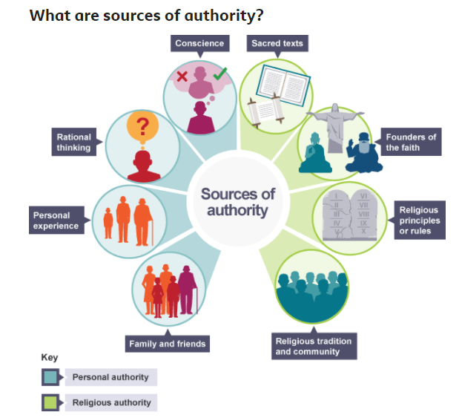

Crossroads Kids’ Club – God’s Story: The Bible https://www.youtube.com/watch?v=dv8dHsxjLd8&t=2s

The Big Frieze (Emma Yarlett) http://www.understandingchristianity.org.uk/the-project/the-big-frieze-emma-yarlett/

The Ten Commandments https://www.youtube.com/watch?v=Z48J3WBHluY

Double Entry Journal:
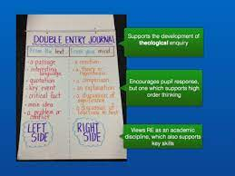

Taken from ‘Better Together in RE Enquiry Based Learning’

https://www.dioceseofnorwich.org/app/uploads/2019/08/Handbook_for_teachers.pdf

The Bible Project https://www.youtube.com/user/jointhebibleproject

The Law https://www.youtube.com/watch?v=3BGO9Mmd_cU

Sacrifice and Atonement https://www.youtube.com/watch?v=G_OlRWGLdnw&t=5s

Messiah https://www.youtube.com/watch?v=3dEh25pduQ8

Who is Jesus? https://www.youtube.com/watch?v=p7XRPGzL6kk

Art Idea:

