Religious Education and Worldviews
Knowledge Organiser to support the Norfolk Agreed Syllabus
Year Group: 3
Enquiry: 4
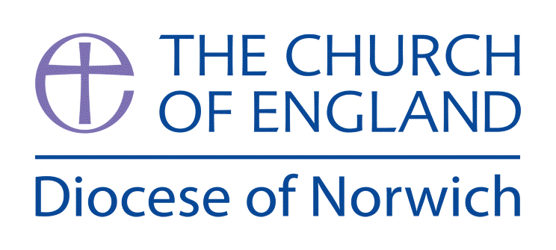

What do Muslims believe about God?

(Intention) What we intend to cover in our learning: (Topic web of concepts here)

Session 1 and 2: Guide the children to a website where they can find the meaning of their name? Do they know why their name was chosen? Does it reflect their character? Show the children some artwork of the 99 names of Allah. Explain that in the Muslim faith they do not portray Allah or the Prophet Muhammad (pbuh). Allah has many different descriptions and it is hard to represent him in a few words, so the Qur’an teaches that Allah has 99 names. Each of the 99 names relates to a particular attribute of Allah, making him easier to understand and relate to.

Engage

Session 3: Islam is a monotheistic religion. In its basic form, Tawhid is the assertation that there is only one God. Watch https://www.bbc.co.uk/teach/class-clips-video/religious-education-ks2-my-life-my-religion-the-quran/z4p8mfr Afterwards, collect questions that they have (KWL Chart) to look at again in Evaluate part.

Enquire and Explore

Session 4: The Qur’an - Introduce the Qur’an to the children, demonstrating how to treat it with care and respect.
Mindmap Surah 112-4 from the Qur’an (see Resources).
This passage sums up the nature of God and is one that many Muslims will learn by heart.

Session 5: The First Pillar of Islam – Shahadah. Look at the PowerPoint and videos about the Shahadah. Children to create a display (Working Wall) about the importance of the statement. Can they create questions from the 5Ws and 1H Who? What? When? Where? Why? How? Can they answer them?

Session 6: Muslims believe that Allah sent many prophets to Earth to give his message. A prophet is someone who speaks for God on Earth. https://www.bbc.co.uk/programmes/p02mwjsw Children to create a timeline of the life of the Prophet Muhammad and decide what symbols to use for different events in his life.

Evaluate
Session 7: Return to questions from Session 3. Have they all been answered? Can the children answer the BIG question? Evaluate the information that we now have about Islam, and how Muslims view Allah. Identify similarities and differences between this and the Christian view of God. Discuss how the Abrahamic religions relate to one another and how they differ in belief and practice.

Session 8: Artwork – select enough choices from the 99 Names of Allah for your class to have one each. Children to create a piece of artwork that represents the characteristic of the name they have been given. Create your own Class Gallery.

Express

(Implementation) Key words I will use and need to know:

Allah Muhammad (pbuh) Prophet
Muslim Qur’an Shahadah
Recitation Revelation Tawhid

(Implementation) Key information we will learn:
- The concept of Tawhid.
- The impact of Tawhid on Muslims.
- The impact of The Qur’an containing the actual words of God.
- How the existence of God is explained in Muslim teachings.
- How the Muslim view of deity differs from that of other religions.

(Implementation) Things to do and find out at home:

Review your key knowledge:
http://www.primaryhomeworkhelp.co.uk/religion/Islam.htm

Watch a story:
The Islamic Stories of The Prophet and the Ants and The Crying Camel
https://www.youtube.com/watch?v=_bN7KIMmwlc

Colour some Islamic Art patterns:
http://www.supercoloring.com/coloring-pages/arts-culture/islamic-art

(Implementation) Some key information you can find more out about:
- The concept of Tawhid (there is only one God). The impact of Tawhid on Muslims.
https://www.bbc.co.uk/teach/class-clips-video/religious-studies-ks2-what-is-islam/zbmrwty

- The impact of The Qur’an containing the actual words of God.
https://www.bbc.co.uk/teach/class-clips-video/religious-education-ks2-my-life-my-religion-the-quran/z4p8mfr

- How the existence of God is explained in Muslim teachings.
https://www.bbc.co.uk/bitesize/clips/z4fgkqt

- How the Muslim view of deity differs from that of other religions.
https://www.bbc.co.uk/bitesize/clips/z9b9jxs

(Impact) What we will aim to do at the end of our learning:
By the end of our learning we will
- Show awareness of the Qur’an as the supreme source of authority for Muslims and begin to explore its authorship and organisation.
- Identify ways in which the Muslim view of Allah is similar to and different from the Christian view of God.
- Begin to understand this in the context of the three Abrahamic religions.
- Recognise ways in which the Muslim view of Allah influences the way Muslims live their lives and view other people.
- Recognise that there are many different answers to the question, ‘What is God like?’

(Impact) The RE Age Related Expectations we will cover and be assessed against:
Theology
- Where beliefs come from Show awareness of different sources of authority and how they link with beliefs.
- Where beliefs come from Identify different types of writing and give an example of how a believer might interpret a source of authority
- How beliefs relate to each other Identify some links between beliefs being studied within a religion or worldview.
- How beliefs shape the way believers see the world and each other Recognise ways in which beliefs might make a Muslim think about how they live their life, how they see the world in which they live and how they view others.

Supplementary Ideas:

BBC Bitesize – Muhammad, Allah and the Koran https://www.bbc.co.uk/bitesize/clips/z9b9jxs

BBC Teach – My Life My Religion: Islam – The Qur’an https://www.bbc.co.uk/teach/class-clips-video/religious-education-ks2-my-life-my-religion-the-quran/z4p8mfr

The First Pillar of Islam – Shahadah https://www.twinkl.co.uk/resource/the-first-pillar-of-islam-shahadah-ks2-powerpoint-and-worksheet-pack-t-re-7173

Respect for the Qur’an

If you can, use real artefacts for this, and demonstrate the first four signs of respect in the classroom – but if not, pictures will do nicely. Teach the children that a Muslim person shows that the words of the Qur’an are holy to him or her in these ways:

1. The Quran has a stand – it is never put on the floor.

2. The Qur’an is wrapped in a silk cloth, so it never gets dirty

3. When you want to read it, you wash your hands first.

4. When you put it way, it is kept on a high shelf, above all other books

5. Muslims try to do what the Qur’an says.

6. Some Muslims learn the whole Qur’an off by heart!

7. Muslims learn Arabic, so they can read the Qur’an in its original language

Resources:

Sources of Authority https://www.bbc.co.uk/bitesize/guides/zfhf9j6/revision/1

Mindmap Surah 112-4 from the Qur’an https://www.hoddereducation.co.uk/media/Documents/RS/Chapter_7_Islam_Beliefs_and_Teachings_sample_material.pdf p. 6

The Shahadah

https://www.youtube.com/watch?v=Z1uYIpD_SyE

https://www.bbc.co.uk/bitesize/clips/zstfgk7

The 99 Names of God: An Illustrated Guide for Young and Old

https://www.amazon.co.uk/99-Names-God-Illustrated-Guide/dp/0957138822/ref=sr_1_1?dchild=1&keywords=99+names+of+god&qid=1624226868&sr=8-1

Art ideas: 99 Names of God

https://www.mamateachesme.com/2018/06/01/teaching-our-children-the-99-names-of-allah-with-kitabkids/

