Religious Education and Worldviews
Knowledge Organiser to support the Norfolk Agreed Syllabus
Year Group: 3
Enquiry: 2
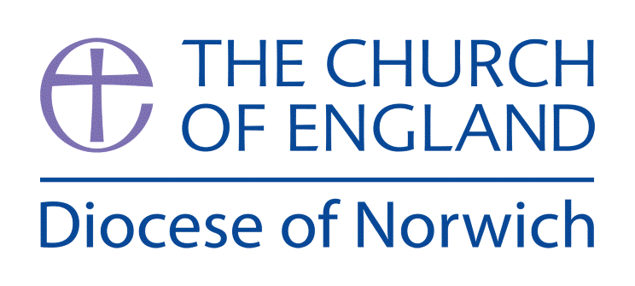

What is the Trinity?

(Intention) What we intend to cover in our learning: (Topic web of concepts here)

Engage
Session 1 and 2: Look at the two pieces of artwork: The Baptism of the Christ with Dove by Daniel Bonnell and The Baptism of Christ by Andrea del Verrocchio and Leonardo da Vinci and use the Silent Discussion technique to allow children to comment on them.
Discuss similarities and differences between how the different painters show God. Christians believe God is three in one: Father, Son and Holy Spirit. Ask pupils to list the evidence for this belief in the pictures.

Session 3: Explain that the Christian religion is Montheistic (a belief in one God). It is important to realise that this does not mean that Christians believe in three gods; they do not. Christians believe in one God that has three parts. Collect questions that they have (KWL Chart) to look at again in Evaluate part.

Enquire and Explore

Session 4: The Nature of God – the Father. Use REQuest: God the Father to introduce this session. Use Double-Entry Journal to explore the parable of The Prodigal Son in greater depth. Focus the children’s learning on exploring the nature of God the Father through the parable. Children to explore how this parable might make a difference to the way a Christian thinks about their life and how they see the world.

Session 5: The Nature of God – the Son. Use REQuest: God the Son to introduce this session. Show the children the images that symbolise Incarnation and Salvation from the Understanding Christianity resource. Ask them to explain in their own words the symbolism in these images. Children to explore how this belief might make a difference to the way a Christian thinks about their life and how they see the world.

Session 6: The Nature of God – the Holy Spirit. Use REQuest: The Holy Spirit to introduce this session. Look at Galatians 5:22-23 But the Spirit produces love, joy, peace, patience, kindness, goodness, faithfulness, humility and self-control. Children to explore how this Bible verse might make a difference to the way a Christian thinks about their life and how they see the world.
Evaluate

Session 7: Return to questions from Session 3. Have they all been answered? Can the children now answer them all by using examples from sessions 3 – 6? Use 3.1 God Resource Sheet 6 Trinity Texts to evaluate the children’s understanding.

Express
Session 8: Children to express their understanding in symbols and art — use a triangle,
a triptych or a three-piece Venn diagram and ask pupils to design a work of art for a church called
‘Holy Trinity’. Ask them to write a short piece to explain their artwork and to answer the ‘Big Question’.

(Implementation) Key words I will use and need to know:

Baptism Father Son Holy Spirit
Gospel Incarnation Salvation Trinity
Monotheistic God Symbol

(Implementation) Key information we will learn:
- God: Christian belief in one God, who is described as Trinity (Father, Son, Holy Spirit).
- Jesus: As God incarnate, also known as the Son of God.
- Incarnation: Jesus as one of the three persons of the Trinity.
- Holy Spirit: God as spiritually active in the world.

(Implementation) Things to do and find out at home:

Evaluate your knowledge of The Trinity by watching: https://www.youtube.com/watch?v=n-1AdUwbWLw

Explore the gifts of the Holy Spirit: https://www.youtube.com/watch?v=YF8Rdn7lEFU

Explore some other pieces of art that represent the Trinity. Do you like the classic or modern ideas?

(Implementation) Some key information you can find more out about:
- Christian belief in one God
https://www.bbc.co.uk/programmes/p02mwvwt
- Jesus: As God incarnate
https://request.org.uk/festivals/christmas/the-first-christmas/#
https://request.org.uk/jesus/death-and-resurrection/why-did-jesus-die/#
- Holy Spirt active in the world today
https://request.org.uk/issues/ultimate-questions/big-questions-what-are-the-gifts-of-the-spirit/
https://request.org.uk/life/a-jamaican-miracle-gods-generosity/

(Impact) What we will aim to do at the end of our learning:
By the end of our learning we will
- Show awareness of the Biblical origins of Christian teachings of the Trinity.
- Identify different types/genres of writing within the Bible.
- Give examples of how Christians might express their beliefs about the Trinity (e.g. in art or literature).
- Identify how Christian baptism uses and expresses the doctrine of Trinity.
- Recognise ways in which belief in the Trinity might make a difference to the way a Christian thinks about their life and how they see the world.

(Impact) The RE Age Related Expectations we will cover and be assessed against:
Theology
- Where beliefs come from Show awareness of different sources of authority and how they link with beliefs.
- Where beliefs come from Identify different types of writing and give an example of how a believer might interpret a source of authority
- How beliefs relate to each other Identify some links between beliefs being studied within a religion or worldview.
- How beliefs shape the way believers see the world and each other Recognise ways in which beliefs might make a Christian think about how they live their life, how they see the world in which they live and how they view others.

Supplementary Ideas:

REQuest has a helpful section on this topic:

REQuest – What is the Trinity? https://request.org.uk/life/beliefs/christianity-basically-the-trinity/

RE Quest – Trinity: God the Father https://request.org.uk/life/beliefs/christianity-basically-father-god/

REQuest – Trinity: God the Son https://request.org.uk/life/beliefs/christianity-basically-jesus-christ/#

REQuest – Trinity: The Holy Spirit https://request.org.uk/life/beliefs/christianity-basically-the-holy-spirit/

REQuest – The Trinity: The Gifts of the Holy Spirit https://request.org.uk/issues/ultimate-questions/big-questions-what-are-the-gifts-of-the-spirit/

Saddleback Kids: The Baptism of Jesus https://www.youtube.com/watch?v=_VMNO2MAmwA&t=6s

Saddleback Kids: The Prodigal Son https://www.youtube.com/watch?v=DJgROx4wFKM

Saddleback Kids: The Story of Easter (Jesus’ Sacrifice) https://www.youtube.com/watch?v=HL8R158Ujp4&t=1s

Saddleback Kids: God Sends the Holy Spirit

Silent Discussion:

Stick images onto large pieces of paper and place them on table tops.

Groups move in silence from table to table, adding notes in the following colours:

• Red for questions.

• Green for comments.

• Blue for answers and comments in response to peers.

This allows all pupils to offer their thoughts. The notes can be kept and referred to in later discussion.

Double Entry Journal:
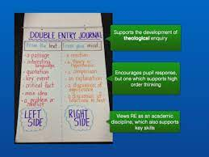

Taken from ‘Better Together in RE Enquiry Based Learning’

https://www.dioceseofnorwich.org/app/uploads/2019/08/Handbook_for_teachers.pdf

