Religious Education and Worldviews

Knowledge Organiser to support the Norfolk Agreed Syllabus

Year Group: 2

Enquiry: 4

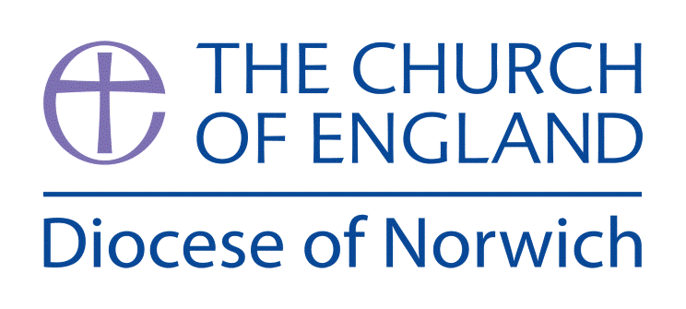

**How do Jews celebrate Passover (Pesach)?**

**(Intention) What we intend to cover in our learning: (Topic web of concepts here)**

Session 1: Explain to the children that in RE we will be answering and exploring the big question ‘What happens at Pesach (Passover) and why is it important for Jews?’

Ask the children what things we celebrate? How do we celebrate these events/festivals? When do we celebrate these festivals/events? Why do we celebrate these events/festivals?

Independent- Children to draw different festivals/events and talk about how we celebrate them and why.

Session 2: Remind the children of the work from last lesson. Ask children to share with their partner different festivals and special events. Remind the children of the big question What happens at Pesach (Passover) and why it is important for Jews? Ask children to think of questions that will help us to investigate and explore the big question. To use different artefacts of Passover.

Session 3: Participated in a Passover meal. Looked at the different foods and what they symbolised. Hear the story of Moses. A good version fo this can be accessed here: <https://youtu.be/aG2TKC6KU8k>

Session 4: Godly Play- Exodus

Tell the story of Moses Children then have responsive time using art, role play and writing options. Make own Seder plate and use to re-enact a Passover meal. Relate the Seder plate to the story of the Passover in the context of Exodus

Session 5: Watch a piece of media about the Seder meal and connected family traditions. Listen to members of the Jewish community tell their own stories of Passover. A superb resource is on True Tube (free login access) the website is: <https://s3.amazonaws.com/truetube.co.uk-files/tt_1949.mp4>

Session 6: What have we learned about the Pesach (Passover) and why it is important for Jews?

Recap all the different questions the children investigated and what they found out. Refer back to the big question ‘What happens at Pesach (Passover) and why is it important for Jews?’ Ask the children if we can now answer this question. Take feedback.

Independent- children to draw/write/make something that they have learnt from this unit of work.

Plenary- children to share their independent work.

**(Implementation) Key words I will use and need to know:**

Matzah bread Moses Passover Pesach

Seder plate

**(Implementation) Key information we will learn:**

* What is the Seder Meal.
* The story of the Passover in the context of Exodus.
* Symbolism of each part of the Seder plate (bitter herbs, Charoset, Karpas, Zeroah, Beitzah and Three Matzot)
* Jewish family traditions related to Passover.
* The importance of Moses within Judaism.

**(Implementation) Things to do and find out at home:**

* Research what Judaism is – a good website to use is: [www.bbc.co.uk/bitesize/topics/znwhfg8/articles/zh77vk7](http://www.bbc.co.uk/bitesize/topics/znwhfg8/articles/zh77vk7)
* Design your own Seder plate – what would you include and why?
* Watch the story of Moses and draw some of the main events in a picture board.

**(Implementation) Some key information you can find more out about:**

* What is the Seder Meal, find out more here: [www.chabad.org/kids/article_cdo/aid/1608/jewish/The-Seder-Plate.htm](http://www.chabad.org/kids/article_cdo/aid/1608/jewish/The-Seder-Plate.htm)
* The story of the Passover in the context of Exodus, find out more here: [www.chabad.org/holidays/passover/pesach_cdo/aid/1827/jewish/The-Passover-Story-in-Short.htm](http://www.chabad.org/holidays/passover/pesach_cdo/aid/1827/jewish/The-Passover-Story-in-Short.htm)
* Symbolism of each part of the Seder plate (bitter herbs, Charoset, Karpas, Zeroah, Beitzah and Three Matzot) to find out more use this website: <https://en.wikipedia.org/wiki/Passover_Seder_plate>
* Jewish family traditions related to Passover, more info at <https://israelmyglory.org/article/fun-food-family-the-traditions-of-passover/>
* The importance of Moses within Judaism, more info here: [www.bbc.co.uk/religion/religions/judaism/history/moses_1.shtml](http://www.bbc.co.uk/religion/religions/judaism/history/moses_1.shtml)

**(Impact) What we will aim to do at the end of our learning:**

By the end of our learning we will

* Recognise that Passover (Pesach) is a Jewish festival.
* Identify ways in which Passover can have an impact on Jewish daily life and family.
* Identify evidence of religion and belief especially in the local area (through visit to Synagogue/Visiting Jew).

**(Impact) The RE Age Related Expectations we will cover and be assessed against:**

**Social Human Sciences**

1. **The diverse nature of religion**

Recognise the names of different religions, religious beliefs and worldviews and use them correctly.

1. **Diverse ways in which people practice and express beliefs**

Identify evidence of religion and belief especially in the local area.

1. **The ways in which beliefs shape individual identity, and impact on communities and society and vice versa**

Identify ways in which beliefs can have an impact on a believer’s daily life, their family or local community.