Religious Education and Worldviews

Knowledge Organiser to support the Norfolk Agreed Syllabus

Year Group: 2

Enquiry: 1

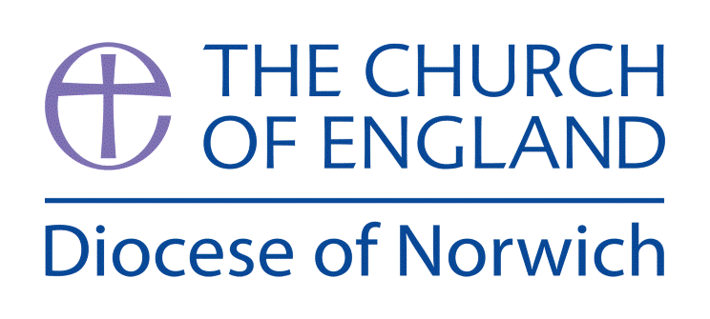

**Why is light and important symbol?**

**(Intention) What we intend to cover in our learning: (Topic web of concepts here)**

Session 1:Explain to the children that in RE we will be answering and exploring the big question ‘Why is light an important symbol for Christians, Jews and Hindus?’

Ask the chn what things provide us with light? Why do we need light? How does it keep us safe? When do we need light? What are natural light sources? What are man-made light sources? How are different light sources made? Why are light sources important? Independent- Children to draw different light sources.

Session 2: Remind the chn of the work from last lesson. Ask children to share with their partner different light sources. Remind the children of the big question Why is light an important symbol for Christians, Jews and Hindus? Using different images, ask children to think of questions that will help us to investigate and explore the big question.

Session 3: Godly Play- The Holy Family.

Tell the story of the Holy Family. Children then have responsive time, model the ‘I wonders…’

Session 4: Explore what a Christingle service is and the meaning behind it. Look at different Christingles. Use [www.childrenssociety.org.uk/how-you-can-help/fundraise-and-events/christingle/what-is-christingle](http://www.childrenssociety.org.uk/how-you-can-help/fundraise-and-events/christingle/what-is-christingle) to support this. Children to them design and make their Christingle

Plenary- Come together to share what the children have made. Ask the children ‘Why is light is an important symbol to Christians?’ Note children’s responses.

Session 5: Read the Christmas Story. Talk about Jesus being the light of the world/to save us/Giving us hope etc.

Use the big Frieze from Understanding Christianity- Section ‘Incarnation’

Ask the children to look at frieze and ask question, talk about what they can see.

Give children a small piece of paper. Children to draw their own images of Christmas/Symbol of light.

Plenary- Share the different images to create class frieze.

Session 6: Read the Story ‘Light the Lights’

Show the bbc video about Hanukkah: [www.bbc.co.uk/bitesize/topics/znwhfg8/articles/zj446v4](http://www.bbc.co.uk/bitesize/topics/znwhfg8/articles/zj446v4). Discuss different customs and traditions of Hanukkah. Talk about the meaning being Hanukkah and why Jews celebrate Hanukkah.

Carousel of activities. 1) Make potato Latkes 2) Make a driedel and play 3) Make Hanukkah cards 4) Make a Menorah using art straws and tissue paper 5) Make coins and envelopes.

Plenary- Come together to share what the children have made. Ask the children ‘Why is light is an important symbol to Jews?’ Note children’s responses.

Session 7:

Read the story of Rama and Sita. Talk about why the light is important. Independently 1) Write the story- use the story board.

2) Make rangoli patterns out of chalk/pastels on black paper 3) Make Diya lamps (allow to set and decorate another day)

Plenary- Read Dipals Diwali book. Ask the children ‘Why is light is an important symbol to Hindus?’ Note children’s responses.

Session 8: What have we learned about the symbol of light in different religions?

Recap all the different questions the children investigated and what they found out. Refer back to the big question ‘ Why is light an important symbol for Christians, Jews and Hindus?’ Ask the chn if we can now answer this question. Take feedback. Independent- chn to draw/write/make something that they have learnt from this unit of work.

Plenary- chn to share their independent work.

**(Implementation) Key words I will use and need to know:**

Diwali Hannukiah Hanukkah

Menorah Shabbat Symbolism

Worship

**(Implementation) Key information we will learn:**

* The Christian belief that Jesus is the Light of The World (John 8:12).
* How the Diwali story reflects Hindu beliefs about good and evil.
* How the Hanukkah story reflects Jewish beliefs about God as provider.
* The symbolic meaning of lighting the Shabbat Candle.

**(Implementation) Things to do and find out at home:**

* **Explore and design diva lamps as part of Diwali. You can find out more here:** [**www.bbc.co.uk/cbeebies/watch/lets-celebrate-diwali**](http://www.bbc.co.uk/cbeebies/watch/lets-celebrate-diwali)
* **Learn about the story of Hanukkah and why light is so important here:** [**www.bbc.co.uk/teach/class-clips-video/religious-studies-ks1-the-jewish-story-of-hanukkah/z47wxyc**](http://www.bbc.co.uk/teach/class-clips-video/religious-studies-ks1-the-jewish-story-of-hanukkah/z47wxyc)
* **Design and make your own Christingle or learn the Christingle song – to find out more look here:** [**https://youtu.be/yvtpwWIqzMw**](https://youtu.be/yvtpwWIqzMw)

**(Implementation) Some key information you can find more out about:**

* The Christian belief that Jesus is the Light of The World (John 8:12). More explanation about this can be accessed here: <https://connectusfund.org/john-8-12-meaning-of-i-am-the-light-of-the-world>
* How the Diwali story reflects Hindu beliefs about good and evil. Further information is available here: [www.trafalgar.com/real-word/diwali-story/](http://www.trafalgar.com/real-word/diwali-story/)
* How the Hanukkah story reflects Jewish beliefs about God as provider. Further information can be accessed here: <https://reformjudaism.org/jewish-holidays/hanukkah/history-hanukkah-story>

**(Impact) What we will aim to do at the end of our learning:**

By the end of our learning we will

* Retell at least one narrative where light is an important symbol.
* Recognise that the narratives used by Christians, Hindus and Jews reflect their key beliefs.
* Give an example of how Christians, Hindus and Jews use beliefs (and the symbolism of light) to guide their daily lives.

**(Impact) The RE Age Related Expectations we will cover and be assessed against:**

**Theology**

1. **Where beliefs come from**

Retell a narrative, story or important text from at least one religion or worldview and recognise a link with a belief.

Recognise different types of writing from within one text.

**D. How beliefs shape the way believers see the world and each other**

Give different examples of how ______ beliefs influence daily life