Religious Education and Worldviews

Knowledge Organiser to support the Norfolk Agreed Syllabus

Year Group: 1

Enquiry: 4

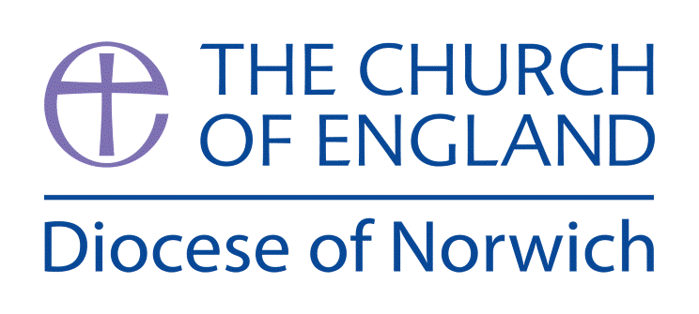

**What does the cross mean to Christians?**

**(Intention) What we intend to cover in our learning: (Topic web of concepts here)**

Session 1:Explore the Easter Story in different media forms e.g. video, drama, artwork, music, some good websites for this include: <https://youtu.be/t2TiXMhATPg> [www.nationalgallery.org.uk/paintings/the-easter-story](http://www.nationalgallery.org.uk/paintings/the-easter-story) What questions does this raise for the children? What do they notice? What might they want to find out?

Session 2: Exploring different crosses and crucifixes explain their symbolism. Use a range of pictures or actual artefacts if you can get them. Visit your local church and look at the different crosses found there. Explore the meaning of the cross as a Christian symbol here: <https://youtu.be/lSwzDgvRl3k>

Session 3: Design and create cards that could be given out by Christians at Easter. Make sure the images and texts communicate Christian beliefs.

Session 4: Invite a member of the Christian Community in to talk about Easter. Can the children get any of their questions answered from their first session?

Session 5: Can the children design and make an Easter Garden and remember the main symbols to include from the Easter story? If it was a modern-day garden – what might be different in it? Why?

Session 6: Discuss why hope is important. Use artwork/music associated with Easter and how it reflects Christian beliefs about hope. Give the children the word HOPE and ask them to draw and or write things they would want to hope for at Easter time. Can they explain why? What might Christian’s hope for? Are these different to what they chose?

**(Implementation) Key words I will use and need to know:**

Christian Cross Crucifixion Jesus

Resurrection Salvation

**(Implementation) Key information we will learn:**

* The Easter narrative in the Bible.
* Christians believe Jesus’ died on a cross (crucifixion) to save people (salvation).
* Christians believe Jesus came back to life (resurrection).
* Christians believe Easter gives people hope of a new life, now and in the future.

**(Implementation) Things to do and find out at home:**

* **Find out about Easter gardens and design or even make your own.**
* **Find out about different ways Easter is celebrated around the world. What do you find that is the same / different, a good website to check this out is:** [**https://youtu.be/YVgZkfHVLC4**](https://youtu.be/YVgZkfHVLC4)
* **Design and make your own cross, great ideas can be found here:** [www.artistshelpingchildren.org/christian-ministry-crafts.html](http://www.artistshelpingchildren.org/christian-ministry-crafts.html)

**(Implementation) Some key information you can find more out about:**

* The Easter narrative in the Bible – a great animated version of the Easter story can be found here: <https://youtu.be/8LhWLz43nQE>
* If Jesus was a superhero what special powers would you give him and what would his superhero costume be? Design a superhero Jesus!
* Explore the symbols of easter that mean new beginnings – research this and draw some of the symbols.

Explore the meaning of Hope here: <https://youtu.be/zh9QaH-qJkM>

**(Impact) What we will aim to do at the end of our learning:**

By the end of our learning we will

* Give a clear, simple account of the Easter Story.
* Recognise that the Easter Story contains Christian beliefs about salvation.
* Recognise that the Easter Story is a source of hope for Christians.

**(Impact) The RE Age Related Expectations we will cover and be assessed against:**

**Theology**

1. **Where beliefs come from** Give a clear, simple account of at least one narrative, story or important text used by at least one religion or worldview.

**C, How beliefs relate to each other** Recognise that narratives, stories and texts used by at

least one religion or worldview contain beliefs.

**D. How beliefs shape the way believers see the world and each other** Give an example

of how Christians use beliefs to guide their daily lives