Religious Education and Worldviews

Knowledge Organiser to support the Norfolk Agreed Syllabus

Year Group: 1

Enquiry: 2

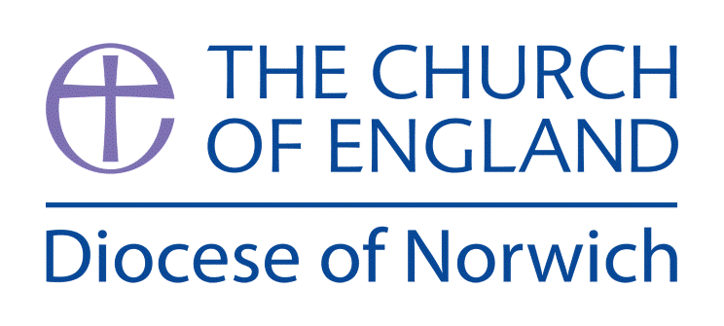

**How does a celebration bring a community together?**

**(Intention) What we intend to cover in our learning: (Topic web of concepts here)**

Session 1:Look at pictures of Christians celebrating together – can the children work out the occasions e.g. Christmas, Easter, Harvest, a Christening, a Wedding etc. Now show the children pictures of Muslims celebrating Eid – what is similar and different? What would the children like to find out from each set of pictures? Make a class question wall.

Session 2: Explore the traditions of Christmas (carol singing, praying, laying out a nativity set, retelling the story of Christmas, posada) in order to understand how a community is drawn together through them. A good video to watch is <https://youtu.be/pdWRVhTM254>

Session 3: Explore artefacts, books and speak to Muslim believers to understand what it means to take part in the celebration of Eid-ul-Fitr, in order to understand how a community is drawn together through them. A good video to watch is <https://youtu.be/gfta93ZdFPs>

Session 4: Visit the local Church to find out how the local Christian community comes together at Christmas. Interview a church leader about importance of celebrations.

Session 5: Explore cross-curricular links with Art or Design Technology by creating traditional celebration food/cards/artwork/music for Christmas and Eid-ul-Fitr. Reflect on how it might bring a community together through shared experience.

**(Implementation) Key words I will use and need to know:**

Celebration Christian Christmas Community Easter Eid-ul-Adha Eid-ul-Fitr Festival Muslim Religion

**(Implementation) Key information we will learn:**

* How Christians celebrate Christmas/Easter.
* How Muslims celebrate (Eid-ul-Fitr and Eid-ul-Adha).
* How these festivals help to bring the religious communities together.

**(Implementation) Things to do and find out at home:**

* **Find out about the different events of Easter and why Christian’s celebrate it here:** [**https://youtu.be/1RWqVX6_Hno**](https://youtu.be/1RWqVX6_Hno)
* **Explore Eid-ul-Adha, the second most important festival to Muslims, by watching this short video** [**https://youtu.be/EjkgX6i5PBM**](https://youtu.be/EjkgX6i5PBM)
* **Make your own Christmas cards or Eid cards to send to friends and relatives.**

**(Implementation) Some key information you can find more out about:**

* The How Christians celebrate Christmas – the traditions of Christmas, including the nativity scenes, the giving of gifts (<https://youtu.be/4YBJNXNlREQ>) and retelling the birth of Jesus (<https://youtu.be/jbQmsIxbx5U>)
* How Muslims celebrate (Eid-ul-Fitr and Eid-ul-Adha) listen to the podcast here: <https://youtu.be/Zv45OvnVNX0>
* How these festivals help to bring the religious communities together, types of communities are explained here: <https://youtu.be/lGC0zxgRNJQ>

**(Impact) What we will aim to do at the end of our learning:**

By the end of our learning we will

* Recognise the meanings of the term Christian and Muslim.
* Recognise practices associated with the festivals of (Christmas) and (Eid-ul-Fitr).
* Recognise ways in which a celebration can encourage a sense of belonging within a faith community.

**(Impact) The RE Age Related Expectations we will cover and be assessed against:**

**Social Human Sciences**

1. **The diverse nature of religion** Recognise that people have different beliefs and that some people follow religions and others non-religious worldviews
2. **The ways in which beliefs shape individual identity, and impact on communities and society and vice versa** Recognise that beliefs can have an impact on a believer’s daily life, their family or local community.