Religious Education and Worldviews

Knowledge Organiser to support the Norfolk Agreed Syllabus

Year Group: EYFS

Enquiry: 1

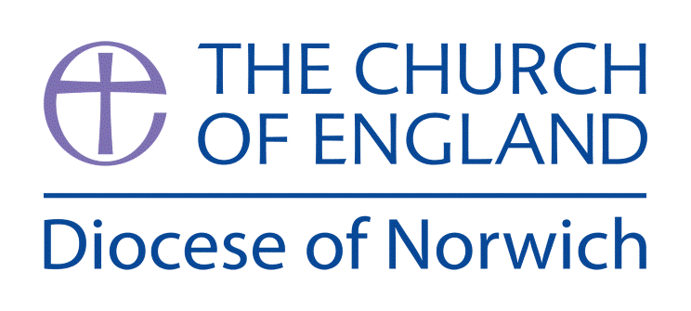

**Why is the word God so important to Christians?**

**(Intention) What we intend to cover in our learning: (Topic web of concepts here)**

Session 1 and 2: This section of learning helps children to learn what the Bible says about God. Introduce the concept that no one has ever seen God but Christians believe he is behind all there is in the world, he is the creator and giver of life. Look at pictures of things God has created and sort them into good / bad – discuss why God might make things we think are bad like spiders or jellyfish? Read to the children the creation story and talk about the different days and events. Can the children role play this? Can they draw a creation they would want in the world? Make collages of animals from the creation story. Learnt he creation song <https://youtu.be/aoehyq6X650>

Session 3,4 and 5: This session explores how Christians show that God is important to them. Look at how Christian’s go to church to come together to sing and pray to God. Look at a church being a place of worship. Watch <https://youtu.be/dxBqcPgx6z0> which explains this briefly. Explore the different reasons to go to church – baptism, festivals, weddings etc. focus on Harvest and what this means and when it happens? Watch <https://youtu.be/5d2Mft72CXg> that explains harvest to children. Ask your local vicar if you could go to church to talk about harvest with your class. Children could learn a harvest song e.g. <https://youtu.be/PukdaXUzgOU> Read to the children A wet and Windy Harvest, make mini-harvest loaves with the children, can the children make a church out of construction materials? In role play can the children make a harvest display using boxes and tins of food? Could the children investigate the autumn fruits and vegetables, use these to print with or make a healthy fruit salad or snack?

Session 6and 7: in this session we think about how Christians respect God’s name and do as the bible says honour it. Introduce the idea of rules and why we have them and link this to the bible having the ten commandments and one being that Christian’s should honour God’s name. watch the video that explains this <https://youtu.be/DRVXkoiuBIs> Talk about how the bible helps teach Christians what to do. How to care and act. Explore how things the children take special care of. Listen to the story of the precious pearl <https://youtu.be/D6-7VDobHFc> and get the children to role play this. Can the children decorate boxes to keep their special pearl safe? Hunt for pearls in sand and or gloop picking them out with tweezers.

Session 8: Think about everything the children have encountered in the topic. How Help is a key theme of the learning – God helped the world by creating everything in it, we say thank you to God for helping grow our food at Harvest. We honour God by following his rules and looking after his creation. How can they help look after things in school or in their life? Make a class book on helping in school and jobs that can be done. Walk around school and get the children to identify jobs to help the school out. Talk to the caretaker about how they help keep the school clean and safe.

**(Implementation) Key words I will use and need to know:**

God Creator Universe

World Creation Christian

Believe Life Steward

Harvest Festival Honour Help

**(Implementation) Key information we will learn:**

* **God is the name Christians use for who they believe created the earth and universe.**
* **God is the creator of all things whether good or bad, he is a life giver.**
* **Christian’s thank God for his creation and giving in a Harvest Festival.**
* **The ten commandments are an important part of Christian living and remind Christians they should honour God’s name.**

**(Implementation) Things to do and find out at home:**

* If you were creating the earth what would you make in it? Draw some things you would create to be on earth.
* Can you visit your local church and see what they do for harvest?
* Harvest is about saying thank you – what would you say thank you for and why? Can your mum or dad write a list of the things you say?
* Go for a walk and spot all of the different things that God created – trees, flowers, animals and birds. Draw a picture of your walk to take into school.
* Read some stories with your parents about animals, nature or creation.

**(Implementation) Some key information you can find more out about:**

* **God is the name Christians use for who they believe created the earth and universe. Watch the video of the creation story here:** [**https://youtu.be/jB_Nbwc0LVo**](https://youtu.be/jB_Nbwc0LVo)
* **Christian’s thank God for his creation and giving in a Harvest Festival. Explore how Christian’s celebrate a Harvest Festival here:** [**www.bbc.co.uk/programmes/p0114rn0**](http://www.bbc.co.uk/programmes/p0114rn0)
* **The ten commandments are an important part of Christian living and remind Christians they should honour God’s name. watch the video about how the ten commandments came to be:** [**https://youtu.be/B9R8rX0R5Z0**](https://youtu.be/B9R8rX0R5Z0)

**(Impact) What we will aim to do at the end of our learning:**

By the end of our learning we will

* The word God is a name
* Christians believe God is the creator of the universe
* Christians believe God made our wonderful world and we should look after it

**(Impact) The RE Age Related Expectations we will cover and be assessed against:**

The Age Related Expectations do not apply to EYFS and it is suggested assessment is made using the foundation stage profile areas of learning instead. The ELGs that can be used include:

* Communication and language development
* Personal, social and emotional development
* Literacy
* Understanding the world
* Expressive arts and design