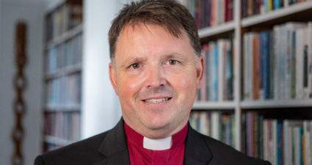

God calls. God calls us in our lives in all kinds of ways, often to what we think at first is impossible. As I hear the stories of those who are sensing a call to ordination it is to this sense of the impossible, with a slow realisation that God’s call is persistent and others are sensing it in that person as well, that always amazes me. This is often especially true for those who respond to be Self-Supporting Ministers (SSM), often via a road that has been a long and winding one.

In the Diocese of Norwich we are blessed with many who give in ministry in this way. Self-Supporting Ministry, like all ministry, is both a privilege and a joy. It’s a privilege to be trained and supported to make a free gift of one’s time and energy to God. It’s a joy to serve God’s people in all the ways that Self-Supporting Ministry can, in all the places it can reach.

As we seek Christ in “ten thousand places”, Self-Supporting Ministers build bridges, hold strands of life in tension, and live on thresholds and in ambiguity, whilst seeking out God in God’s world and in God’s people as they do their work to God’s glory, making God explicit wherever they go.

We are praying in the Diocese of Norwich that God will continue to send more harvesters to the vineyard. We are keen to increase the number of Self-Supporting Ministers. So, is God calling you? Or do you know someone who God might be calling, even if that seems impossible for now?

+Graham Norvic: