**RE Planning Cycle Template**

Unit Focus/ Year Groups:

1. Engage

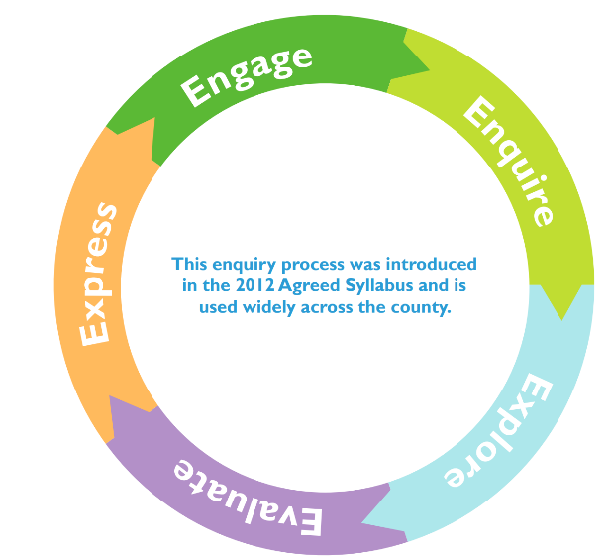

3. Explore

4. Evaluate

5. Express

2. Enquire