Bishop’s Day of Prayer
on the Eve of Pentecost
Saturday 22 May 2021

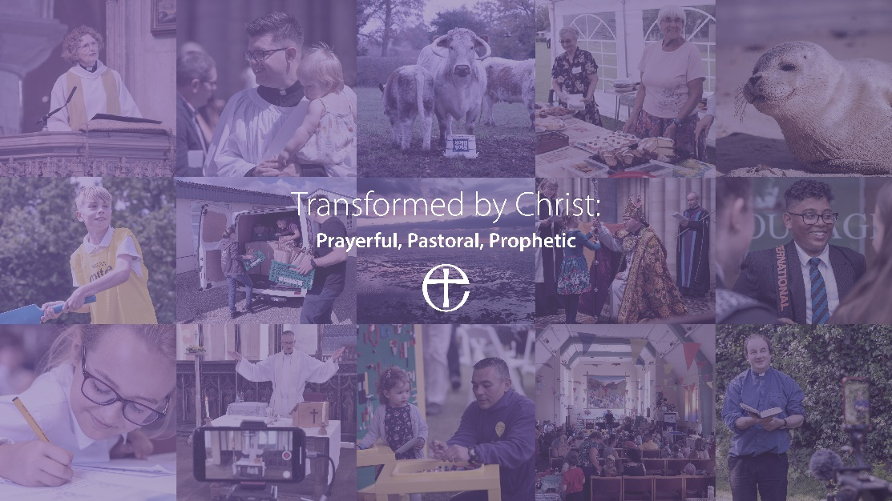

holding before God the life of our diocese
and praying for our new Vision…

Transformed by Christ:
Prayerful Pastoral Prophetic

Opening Worship

Greeting and gathering

The light and peace of Jesus Christ be with you
All and also with you

Summoned by the God who made us
rich in our diversity,
gathered in the name of Jesus,
richer still in unity:

All let us bring the gifts that differ
and, in splendid varied ways,
sing a new Church into being,
one in faith and love and praise.

Trust the goodness of creation;
trust the Spirit strong within,
dare to dream the vision promised,
sprung from seed of what has been.

Bring the hopes of every nation;
bring the art of every race.
Weave a song of peace and justice;
let it sound through time and space.

All Let us bring the gifts that differ
and, in splendid varied ways,
sing a new Church into being,
one in faith and love and praise.

Delores Dufner

Bishop Welcome and introduction to the service

Thus says the Lord:
“See, I am doing a new thing!
Now it springs up; do you not perceive it?” Isaiah 43.19

At the outset of this day of prayer, we look to the future with hope: as we begin to emerge out of lockdown, we share a new vision for our life and growth and wait together on this eve of Pentecost for the winds of the Spirit to blow through our diocese with fresh grace.
But, longing for God’s “new thing” as we are, we must first look back, acknowledging the failures of times past and asking both for God’s forgiveness and for a renewed willingness to be open to Christ’s transforming presence.

Silence for reflection

All Transforming Christ,
bring new life
where we are worn and tired;
new love
where we’ve become hard-hearted;
forgiveness
where we feel hurt or have hurt others;
and the joy and freedom of your Holy Spirit
where we are prisoners of ourselves.

May God forgive you,
Christ befriend you
And the Spirit renew
And change your life
All Amen

Canticle: A Song of the New Creation

All I will make a way in the wilderness,
and rivers in the desert.

1 ‘I am the Lord, your Holy One, •
the Creator of Israel, your King.’

2 Thus says the Lord, who makes a way in the sea, •
a path in the mighty waters,

3 ‘Remember not the former things, •
nor consider the things of old.

4 ‘Behold, I am doing a new thing; •
now it springs forth, do you not perceive it?

5 ‘I will make a way in the wilderness
and rivers in the desert, •
to give drink to my chosen people,

6 ‘The people whom I formed for myself, •
that they might declare my praise.’

All I will make a way in the wilderness,
and rivers in the desert.
Isaiah 43.15, 16, 18, 19, 20c, 21

All Glory to the Father
and to the Son
and to the Holy Spirit;
as it was in the beginning
is now and shall be for ever.
Amen.

Transformed by Christ to become more
PRAYERFUL

Reader A reading from St Matthew’s Gospel.
Listen with the ear of your heart
All Our ears are open:
our hearts are open.

Jesus said to his disciples, “Whenever you pray, do not be like the hypocrites; for they love to stand and pray in the synagogues and at the street corners, so that they may be seen by others. Truly I tell you, they have received their reward. But whenever you pray, go into your room and shut the door and pray to your Father who is in secret; and your Father who sees in secret will reward you.
“When you are praying, do not heap up empty phrases as the Gentiles do; for they think that they will be heard because of their many words. Do not be like them, for your Father knows what you need before you ask him. “Pray then in this way:
All Our Father in heaven,
hallowed be your name.
Your kingdom come.
Your will be done,
on earth as it is in heaven.
Give us this day our daily bread.
And forgive us our debts,
as we also have forgiven our debtors.
And do not bring us to the time of trial,
but rescue us from the evil one.” Matthew 6.5-13

Silence for reflection…

All Transform us O Christ,
that, deeply rooted in prayer,
we may be fully alive to you
and your purposes for us and for all people.
Amen

Transformed by Christ to become more
PASTORAL

Reader A reading from St John’s Gospel.
Listen with the ear of your heart
All Our ears are open:
our hearts are open.

`When they had finished breakfast, Jesus said to Simon Peter, “Simon son of John, do you love me more than these?” He said to him, “Yes, Lord; you know that I love you.” Jesus said to him, “Feed my lambs.” A second time he said to him, “Simon son of John, do you love me?” He said to him, “Yes, Lord; you know that I love you.” Jesus said to him, “Tend my sheep.” He said to him the third time, “Simon son of John, do you love me?” Peter felt hurt because he said to him the third time, “Do you love me?” And he said to him, “Lord, you know everything; you know that I love you.” Jesus said to him, “Feed my sheep.
John 21.15-17

Silence for reflection …

All Transform us O Christ,
that, like Peter,
we may hear you charging us
to shepherd your sheep:
may we too respond for love of you
by feeding the hungry
and tending the vulnerable.
Amen

Transformed by Christ to become more
PROPHETIC

Reader A reading from St Luke’s Gospel.
Listen with the ear of your heart!
All Our ears are open:
our hearts are open.

When he came to Nazareth, where he had been brought up, he went
to the synagogue on the sabbath day, as was his custom. He stood up
to read, and the scroll of the prophet Isaiah was given to him. He unrolled the scroll and found the place where it was written:
‘The Spirit of the Lord is upon me,
because he has anointed me
to bring good news to the poor.
He has sent me to proclaim release to the captives
and recovery of sight to the blind,
to let the oppressed go free,
to proclaim the year of the Lord’s favour.’
And he rolled up the scroll, gave it back to the attendant, and sat
down. The eyes of all in the synagogue were fixed on him.
Then he began to say to them, ‘Today this scripture has been fulfilled in your hearing.’

Luke 4. 16-21

All Transform us, O Christ,
that, inspired by your example,
we may find our voice
to challenge injustice
and stand up for the oppressed.
Amen

Prayers of Intercession
Almighty God, in Christ, you make all things new,
as we pray for Christian communities the world over, we ask for your renewal: where relationships are broken, restore unity;
where commitment has grown cold
and desire for your Kingdom has dulled,
re-kindle in your Church the fire of your love.
All Transform the poverty of our nature by the riches of your grace.

Almighty God, in Christ, you make all things new,
as we pray for your world, we hold in your liberating love those places bound by fear and hatred … Israel and Palestine, Syria, Yemen, Congo…
In the face of despair and devastation,
bring a new hope, a re-building of lives.
All Transform the poverty of our nature by the riches of your grace.

Almighty God, in Christ, you make all things new,
as we pray for ourselves and for the communities from which we come,
we ask for your equipping and encouragement.
Refresh and reinvigorate our clergy, Readers, AWAs and congregations:
re-ignite our longing for you;
re-ignite our longing to share you with those around us.
All Transform the poverty of our nature by the riches of your grace.

Almighty God, in Christ, you make all things new,
as we bring to you all who suffer in body, mind or spirit,
we pray for your wholeness and healing.
May we be alert to the promptings of your Spirit
and so speak up for your just and gentle rule in the world around us.
All Transform the poverty of our nature by the riches of your grace.

Almighty God, in Christ, you make all things new,
as we thank you for those who have gone before us in the way of faith,
we entrust them afresh into your eternal peace.
May those who are grieving be enfolded
in that Love which transforms even death
and face the future renewed by resurrection hope.
All Transform the poverty of our nature by the riches of your grace.
Commission and Blessing
please stand

Empowered by the Holy Spirit, will you dare to walk into God’s future, trusting him to be your guide?
All By the Spirit’s power, we will.

Will you dare to embrace each other and grow together in love?
All We will.

Will you dare to share your riches in common and minister to each other in need?
All We will.

Will you dare to pray for each other until your hearts beat with the longings of God?
All We will.

Will you dare to carry the light of Christ into the world’s dark places?
All We will.

Bishop May God our loving Creator
bless this day of prayer,
and our new Vision at its heart;

May the crucified, risen and ascended Christ
transform those who will pray here today
and all who will be praying at home;

May the empowering Spirit
send us out from here
with a fresh commitment
to be people of prayer,
pastors and prophets.

And the blessing of God almighty,
the Father, the Son and the Holy Spirit
be with you, with the Deaneries from which you come,
and with all the people of this Diocese,
now and always.
All Amen

