Policy for Spiritual Development

As a Church of England school, Dereham Church Infant and Nursery School recognises that the spiritual development of pupils plays a significant part in their ability to learn and achieve.

This policy should be read in conjunction with all other policies.

Our Mission Statement
Develop our children as confident individuals with an appreciation of the Christian faith
Challenge our children in order for them to reach their full potential
Inspire our children through a creative and stimulating curriculum to have enquiring minds and be independent learners
Nurture our children in an environment that supports and promotes well being
Succeed in fostering creative, considerate, confident individuals.

The Aims of the School
At Dereham Church Infant and Nursery School we aim for every child to develop their whole self as an individual, enjoy learning and strive to reach their full potential

In furthering our Christian vision, we aim for our children to:
- Have an awareness of their own and others’ physical, emotional, social understanding and spiritual well-being.
- Have a sense of belonging in our school and wider community whilst respecting the values, opinions, culture and beliefs of others.
- Develop a greater understanding of the Christian faith
- Have a positive, enthusiastic and confident attitude towards lifelong learning
- Know how to keep themselves and others safe within the school and wider community
- Develop an understanding of what it means to be British.

We believe children will achieve these aims by experiencing:
- A safe, secure, stimulating and inclusive learning environment
- A broad, balanced, child-centred curriculum which reflects the community in which we live, work and the wider world
- High quality creative teaching which supports and challenges all learners.
- An ethos which is underpinned by Christian values
- An opportunity to reflect upon their own and others’ beliefs, cultures and values
- A learning partnership between school, parents, carers, governors and the community
- Challenging age appropriate opportunities to develop spiritual, moral, social and emotional well being
- A fair system of rewards and sanctions
- Democracy by voting for the School Council

To ensure we meet our aims, we:
- Shall give high priority to well-being for all
- Place safeguarding at the forefront of all we do.
- Regularly evaluate the effectiveness of teaching, learning and the personal progress of every child.
- Have a coherent and relevant programme of professional development for all staff
- Ensure learning resources are up to date and financial resources are well managed
- Provide opportunities for children to explore Christian beliefs, morals and values through both teaching and educational visits.
- Provide opportunities for children to express their views through the school council
- Celebrate children’s achievements and attendance
- Undertake good communication with parents/carers, governors and the community, involve them in school life.
- Have an agreed system for rewards and sanctions for the consequences of rule breaking
- Reinforce the Mission Statement and rules by having displays throughout school.
- Have curriculum enhancement weeks to increase understanding and respect towards those of different faiths and beliefs

Spiritual Development Guidelines

Ofsted state that the spiritual development of pupils is shown by their:
- ability to be reflective about their own beliefs (religious or otherwise) and perspective on life
- interest in, and respect for, different people’s faiths, feelings and values
- sense of enjoyment and fascination in learning about themselves, others and the world around them
- use of imagination and creativity in their learning
- willingness to reflect on their experiences

(Ofsted, School Inspection Handbook from September 2019)

Spiritual development takes place across all curriculum areas. Activities should be provided so children have opportunities to recognise the spiritual dimension of their learning, reflect on the significance of what they are learning and to recognise any challenges that there may be to their own attitudes and behaviours.
All curriculum areas should seek illustrations and examples drawn from as wide a range of cultural contexts as possible.
Christian spirituality and Christian values and principles will be explored in all curriculum areas, especially RE and Collective Worship, but the integrity and spirituality of children from other faith backgrounds will be respected and explored. The diversity of spiritual traditions will be recognised, and children will be given access to alternative views.
All adults will model and promote expected behaviour, treating all people as unique and valuable individuals.
The school community will be a place where children can find acceptance for themselves as unique individual and where forgiveness and the opportunity to start again is fundamental to the ethos of our school.
Children should learn to differentiate between right and wrong in as far as their actions affect other people. They will be encouraged to value themselves and others.
Children will understand the need for rules and the need to abide by rules for the good of everyone. Class rules should reflect, reiterate, promote and reward acceptable behaviour and promote opportunities to celebrate children’s work and achievements.

Spiritual Development Aims
- To ensure that everyone connected with our school is aware of our values and aims.
- To provide high quality and valued Collective Worship, which allows time for stillness and reflection.
- To develop a consistent approach to spiritual development throughout the school.
- To ensure children, staff, governors and regular volunteers know what is expected of them and why.
- To ensure that lessons are planned within a context that is meaningful and appropriate to children’s age and development.
- To enable children to develop an understanding of their individual and group identity.
- To enable children to begin to develop an understanding of their social and cultural environment and an appreciation of the many cultures which now enrich our society.
- To give each child the opportunity to explore social and moral issues, and develop a sense of social and moral responsibility towards each other, the wider world and the environment.
- To give each child time to reflect on their own personal beliefs whether these are religious or non-religious.
- To provide opportunities to reflect on experiences of awe and wonder, beauty and compassion etc.
- To provide opportunities to explore the distinctive ethos of a Church school and the content, language and symbolism of the Christian faith.
- To provide a safe environment where both children and staff know their self-worth and they are comfortable to take risks and learn from failure.
- Ensure children and staff have a physical place where they can stop to reflect and recharge.
Below are examples of Reflective Areas in the school where children and staff can have a calm place to reflect.

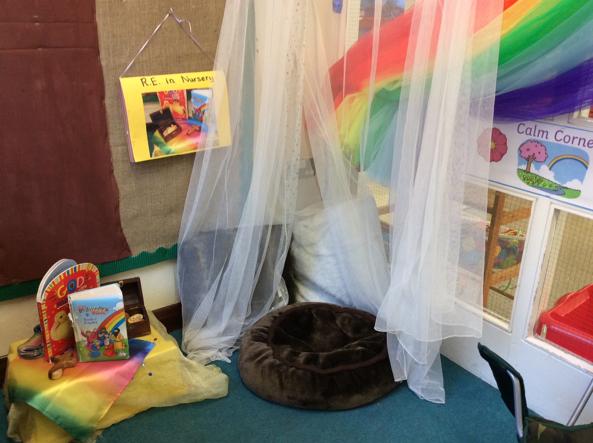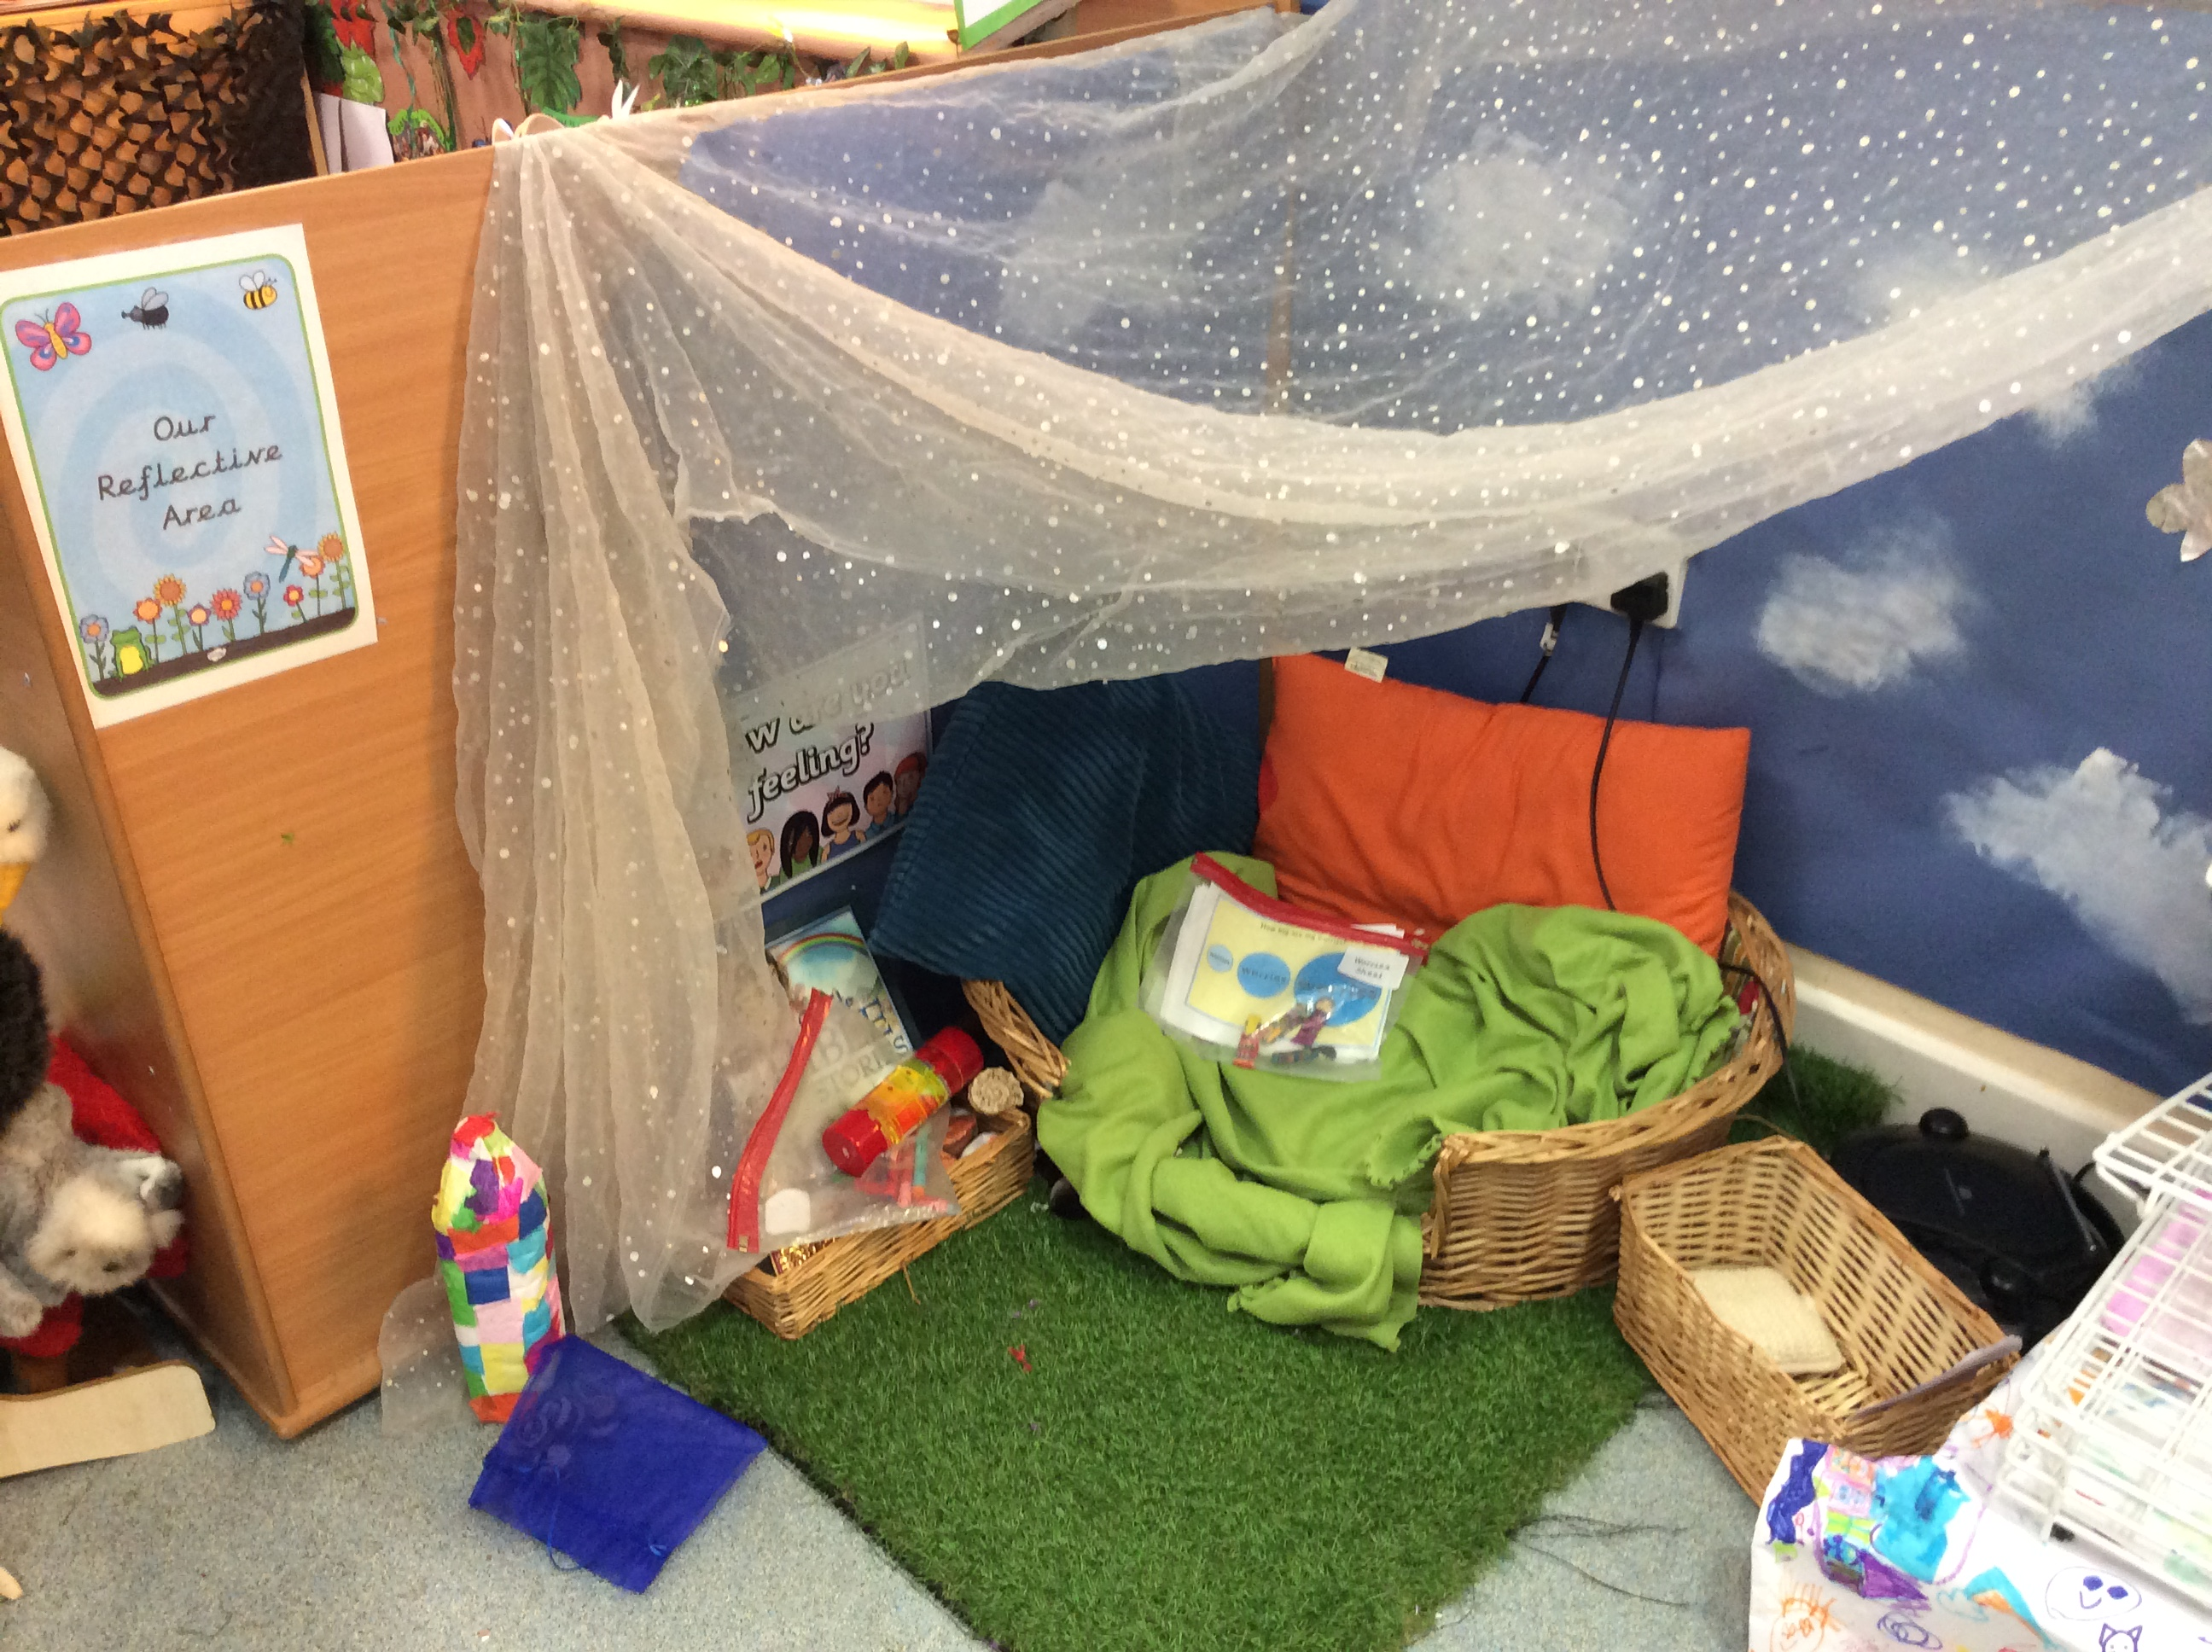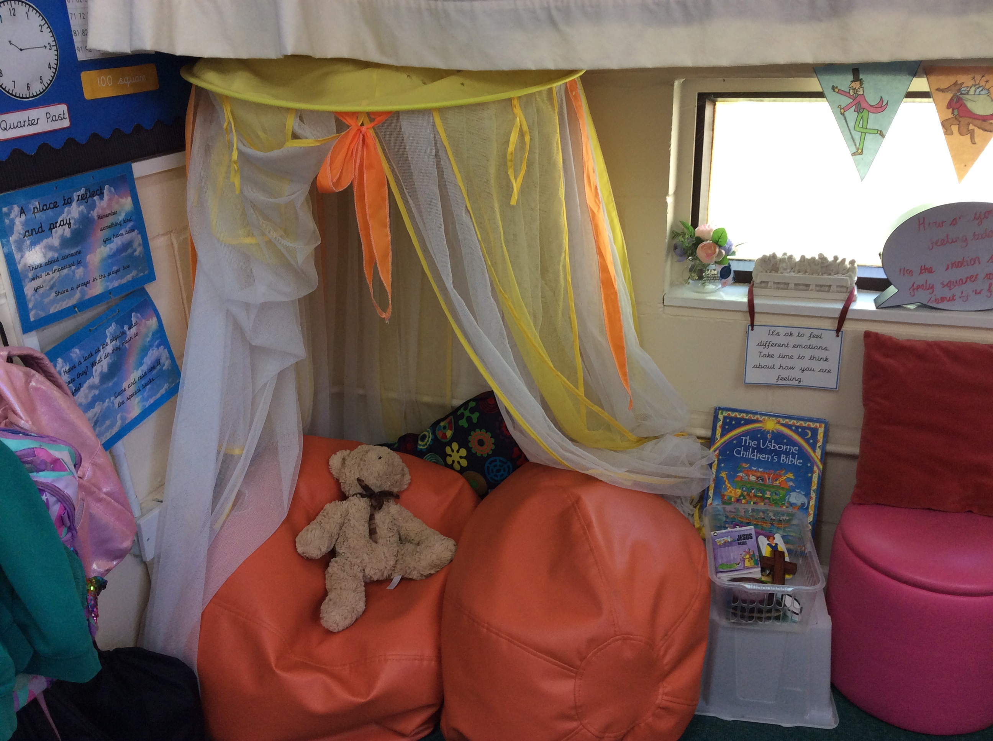

Teaching and Organisation
Class discussions, circle time, Philosophy and Collective Worship will give children opportunities to:
- Develop a sense of self-esteem and self-worth.
- Develop a sense of belonging.
- Develop relationships based on the Christian values of love, forgiveness and service to others.
- Develop their ability to reflect by providing opportunities for silence, stillness and prayer
- Develop the skills and attitudes to enable them to become creative and imaginative thinkers.
- Develop the ability to ask and answer ‘what’, ‘how’, why’, ‘when’ questions.
- Develop an awareness of the wider world and their responsibility towards it.
- Talk about personal experiences and feelings.
- Express and clarify their own ideas and beliefs.
- Speak about difficult events eg. Death, friendship difficulties.
- Share thoughts and feelings with other people.
- Explore relationships with friends/family/others.
- Consider the needs of others and show empathy.
- Explore ‘Big Questions’.
- Use an enquiry approach to learning.

Links with the wider community
- Visitors are welcomed into school.
- Links with the Church are fostered through links with the Parish church, the Diocesan Board of Education and local churches of other Christian denominations.
- The development of a strong home-school link is regarded as very important, enabling parents and staff to work in an effective partnership to support the child.
- Pupils will be taught to appreciate, and to develop a sense of responsibility towards their local environment.
- Links with local charities (EACH), local events (Remembrance service) and local organisations (e.g. old people’s homes).

Monitoring and Evaluation
- Provision for spiritual development will be monitored and reviewed on a regular basis in the following ways:
- Monitoring of lesson plans and teaching and learning by Headteacher/senior leadership/ governors.
- Regular discussion at staff and governors meetings.
- Audit of policies
- Annual audit of Collective Worship and practice.
- Sharing of classroom work and practice.
- Regular inclusion in SIDP.
- Evidence from children’s work e.g. philosophy lesson comments.
- Parent and Children Surveys.

