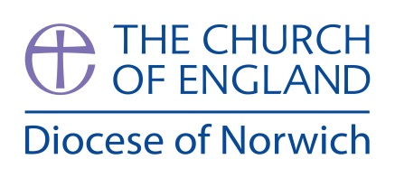
SAMPLE FORM
CONSENT TO VIDEO A CHILD/YOUNG PERSON

Dear Parent/Guardian,

Photos and short video clips are a very effective way of communicating and promoting the value of youth and children’s work. They are also a great way for group members to see themselves enjoying being part of a group and learning from or remembering a particular activity or event.

Occasionally, we may take photographs or video of the children/young people who belong to our group. We may use these images in our publicity or in other printed publications that we produce, as well as on our website/Facebook/You-Tube pages. We may also make video or slideshows of our group in action for educational purposes, including remembering a fun activity or event.

Very occasionally our group may be visited by the media who will take photographs or film footage of a visiting dignitary or other high profile event. Group members may appear in these images, which may appear in newspapers, or even on TV news programmes.

To comply with the Data Protection Act 2018, we need your permission before we can photograph or make any recordings of your child for promotional purposes. Please answer questions 1 to 4 below, then sign and date the form where shown. Please return the completed form as soon as possible.

Please circle your answer.
- May we use your child’s photograph in printed publications that we produce
for promotional purposes or on display boards/banners? Yes / No
- May we use your child’s image on our website and Facebook? Yes / No
- May we record your child’s image on video? Yes / No
- Are you happy for your child to appear in the media? Yes / No

Please also note that the conditions for use of these photographs/videos are on the back of this form.

I have read and understood the conditions of use on the back of this form.

Parents/guardian name
(block capitals):
Parents/guardian’s signature:
Date:
Name of child/young person (block capitals):

Conditions of use
- This form is valid for the period of time your child attends this group / *for this project only. The consent will automatically expire after this time.
- We will not use the personal details or full names (which means first name and surname) of any child or adult in a photo image on video, on our website, in any of our other printed publications.
- We will only use images of young people who are suitably dressed, to reduce any risk of such images being used inappropriately.
- This form and photos will be stored securely and may be used for 12 months after the event and will then be destroyed. If we wish to keep photos beyond this time we will seek express permission”

Please note that the press are exempt from the Data Protection Act and may want to include the names and personal details of children and adults in the media.
* Please delete the option that does not apply.

