

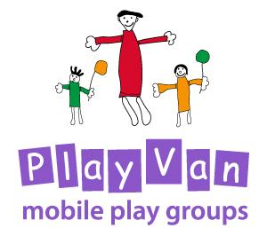

Special Educational Needs and Disabilities

Updated: For review:

March 2020 March 2022

Special Educational Needs and Disabilities Policy

Policy statement

The PlayVan provide an environment in which all children, including those with Special Educational Needs and Disabilities, are supported to reach their full potential.

- We ensure our provision is inclusive of all children with Special Educational Needs and Disabilities (SEND).
- We support parents and children with SEND.
- We support the specific needs of children with SEND and meet those needs through a range of SEND strategies.
- We work in partnership with parents and other agencies in meeting an individual child’s needs.

We seek to supply/adapt equipment as necessary on the advice of supporting agencies to help any child be integrated at all times. We try to ensure that premises are suitable for anyone to attend the sessions.

This policy was adopted by the PlayVan Trustees on ………………………………………

Signed by Chair of the PlayVan……………………………………………………………………..

Review date ……………………………………….

