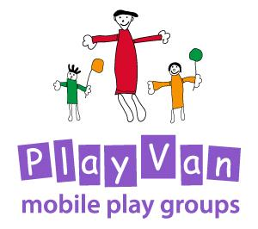

Risk Assessment

Updated: For review:
March 2020 March 2021

Risk Assessment Policy
The PlayVan provides a safe and healthy place for children, parents, staff and volunteers by assessing and minimising the hazards and risks to enable children to thrive in a healthy and safe environment. Our risk assessment procedures are part of a continuous process to prevent any dangerous incidents taking place. They are the responsibility of the Development/PlayVan worker and Trustees.
In accordance with our duties under the Management of Health and Safety at Work Regulations 1999, the PlayVan is required to undertake regular risk assessments and take any necessary action arising from these.
The Development/PlayVan Worker and Trustees are responsible for;
- making sure that risk assessments are completed, logged and effectively monitored.
- reviews are conducted when there is any change to equipment or resources, any change to any PlayVan premises, or when the particular needs of a child or other person necessitates this.
- conducting any necessary reviews or making changes to the PlayVan’s policies or procedures in the light of any potential risks that they or other members of staff discover.
Our risk assessment processes follow five steps:
- Identification of risk or hazard: Where is it and what is it?
- Decide who is at risk and how: For example, staff, volunteers, children, parents/carers, visitors
- Evaluate the risks and decide on precautions – can you get rid of the risk altogether, if not how can you control it?
- Record the findings and implement them – prioritise, make a plan of action if necessary
- Monitoring and review - how do you know if what has been decided is working, or is it thorough enough? If it is not working, it will need to be amended, or maybe there is a better solution.

Procedure
Our risk assessment process covers adults and children. It includes:
- Checking for and noting hazards and risks in our premises and for activities;
- Assessing the level of risk and who might be affected;
- Deciding which areas need attention;
- Developing an action plan that specifies the action required, the time-scales for action, the person responsible for the action and any funding required.
During a PlayVan session, the Development/Playvan Worker will be vigilant and continuously aware of any potential risks to health and safety arising from:
- The environment, both indoors and outdoors
- All surfaces, both indoors and outdoors
- All equipment used by children and/or adults
On discovering a hazard, the Development/PlayVan Worker will take all steps necessary to make themselves and any other people potentially affected, safe. They will then ensure that a written record is made.
The Development/PlayVan Worker, in conjunction with the Trustees, is then responsible for ensuring that any necessary action is taken.

Refer also to Health and Safety Policy

This policy was adopted by the PlayVan Trustees on ………………………………………

Signed by Chair of the PlayVan……………………………………………………………………..

Review date ……………………………………….

