

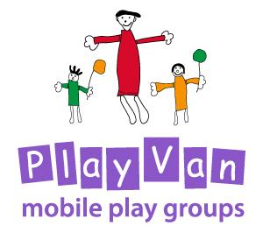

No Smoking Policy

Updated: For review:
March 2020 March 2022

No Smoking Policy

The PlayVan Trustees have developed this policy to protect all children and adults from exposure to second-hand smoke and to assist compliance with the Health Act 2006.

The PlayVan operates a strict no smoking policy both inside and outside the premises.

Appropriate ‘no smoking’ signs will be clearly displayed.

This policy applies to all adults. If an adult does not comply with this no smoking policy, they will be asked to leave the group.

This policy was adopted by the PlayVan Trustees on ………………………………………

Signed by Chair of the PlayVan……………………………………………………………………..

Review date ……………………………………….

