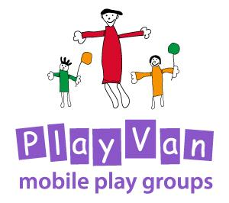

Development Agreement

Updated: For review:
March 2020 March 2022

Development Agreement

Will the group take place within a school? Yes/No

Will the group take place with a church? Yes/No

Will the group take place within a community setting? Yes/No

For groups taking place within a school

Recruitment of volunteers to follow school safe recruitment processes unless specifically agreed otherwise and documented below, including the generation of a DBS check (whereby Church of England Guidance for Safer Recruitment will be followed).

For groups taking place within a church

Recruitment of volunteers to follow church safe recruitment processes unless specifically agreed otherwise and documented below including the generation of a DBS check (whereby Church of England Guidance for Safer Recruitment will be followed). The Safeguarding Policy of the church to be followed where there are safeguarding concerns for a child within the group.

For groups taking place within a community setting

Church of England Guidance for Safer Recruitment will be followed including the generation of a DBS check and use of the Confidential Declaration Form. The Safeguarding Policy of the school to be followed where there are safeguarding concerns for a child within the group.

If DBS checks are returned with issues declared the Play van Safeguarding Designated Trustee, will consult with Sue Brice (Safeguarding Lead for the Diocese) and devise an individual risk assessment, as appropriate.

Please see induction, training and supervision programme that acts as a guide for how volunteers will be supported.

Signed………………………………………………… PlayVan

Signed……………………………………………………. Church/School lead

Date………………………………………………………..

Group Handover Agreement

Has the group taken place within a school? Yes/No

Has the group taken place within a church? Yes/No

Has the group taken place within a community setting? Yes/No

For groups taking place within a school or church

We agree to accept full responsibility for the supervision of volunteers and the safer recruitment, induction and training of new volunteers.

We agree to become responsible for safeguarding within the group. Any concerns for children attending the group will be reported following school safeguarding policies and procedures.

The Play van name and support of the playworker will continue to be retained. However safeguarding oversight will be the responsibility of the school/church.

For groups taking place within a community setting

Will the Play van ever retain responsibility for handing groups back to the community if they’re not in a school or church? Would we ever retain responsibility for safeguarding and the oversight of volunteers if we’re not there every week?

This is really important as it will help guide our strategy on group development.

Signed…………………………………………………… PlayVan

Signed…………………………………………………….Church/School lead

Date………………………………………………………..

