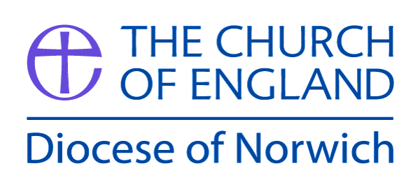

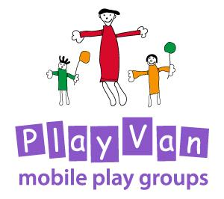

Food Hygiene

Updated: For review:
March 2020 March 2021

Food Hygiene
Each group where food is prepared on or off the site needs to have written procedures on the provision of food.
Food hygiene regulations 2006
On 1 January 2006 food hygiene legislation changed across Europe. The new regulations consolidate and simplify the existing legislation. The main change is the need for some food operations to have a documented food safety management system. The amount of documentation will depend on the size and nature of the operation. Activities such as the occasional preparation of food by individuals or groups for gatherings or for sale at charitable events are excluded. For more regular ‘low’ risk activities where food is brought onto premises, simplified procedures and record keeping should suffice.

A food safety management procedure requires that:
- Hazards to food safety which might be present are identified for example unclean preparation area and children and parents’ crockery and utensils not clean. Controls are in place to deal with these hazards for example, use of sterilisation tablets.
- Controls carried out and if something goes wrong it is clear what should be done to rectify the problem
- Procedures are kept up to date
- Records are kept to demonstrate what the procedures are and if they are working.
Detailed advice on food safety management from the Food Standards Agency can be found at www.food.gov.uk/foodindustry/hygiene/sfbb.
More general information is available from the Food Standards Agency website www.food.gov.uk or from your local environmental health department.

Food Preparation checklist
- Food stored correctly – diary products stored in a refrigerator
- Adult preparing food to wash hands
- Preparation tables and chopping boards are thoroughly cleaned
- Cleanser and kitchen rolls used to clean surface were children are going to eat
- Ensure that all utensils and crockery are cleaned and stored appropriately
- Wet wipes are provided for children to clean their hands before eating

Hygiene
- All toilets and nappy changing areas are checked for cleanliness.
- All cleaning products must be locked away.
- If there is not a facility to dispose of nappies safely, ask parents and carers to take them home. Ideally, nappies should be burned or put into two bags and tied securely before they are thrown away.

This policy was adopted by the PlayVan Trustees on ………………………………………

Signed by Chair of the PlayVan……………………………………………………………………..

Review date ……………………………………….

