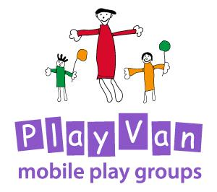

First Aid

Updated: For Review:
March 2020 March 2021

First Aid Policy

The Development/Playvan Worker will administer first aid for adults and children with minor injuries or, in the event of serious incidents, whilst awaiting medical assistance.

The Development/Playvan Worker will be required to be trained in paediatric first aid and to maintain this qualification by attending appropriate and timely ongoing refresher training.

An accident or incident form will be completed where any first aid is administered and
Parents/Carer will be asked to read and counter sign this note.

First Aid Box
- The Development/Playvan Worker will be responsible for checking the first aid kit.

- The first aid kit is easily accessible to adults and is kept out of the reach of children.

- It is checked termly time to ensure all contents are present, in date and packaging is undamaged.

- The first aid kit contains the following items:
- Triangular bandages x 4
- Sterile dressings; small x3, medium x3, large x3
- Composite pack containing assorted individually wrapped plasters x1
- Sterile eye pads with bandage or attachment
- Roll of hypo-allergenic tape
- Protective face shield for performing C.P.R
- Low adherent dressings 5cm x5
- Low adherent dressings 10cm x5
- Finger bandage x1
- Pair of round ended scissors x1
- Pack of 5 gauze swabs x1
- 2 pairs of disposable plastic (PVC or vinyl) gloves
- A children’s forehead ‘strip’ thermometer
- Instant ice pack

Refer also to the Health and Safety Policy

This policy was adopted by the PlayVan Trustees on ………………………………………

Signed by Chair of the PlayVan……………………………………………………………………..

Review date ……………………………………….

