

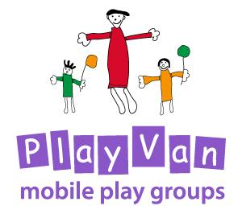

Behaviour and Management

Updated: For review:

March 2020 March 2022

Behaviour Management Policy

Policy statement

We believe that children flourish best when their personal, social and emotional needs are met and where there are clear and developmentally appropriate expectations for their behaviour.

Children need to consider the views and feelings, needs and rights of others and the impact that their behaviour has on people, places and objects. This is a developmental task that requires support, encouragement and modelling by both parents/carers and the group leaders.

Strategies with children who engage in inconsiderate behaviour

- We encourage all parents and carers to use positive strategies for handling any inconsiderate behaviour, by helping children find solutions in ways which are appropriate for their ages and stages of development.
- The Group Leader ensure that there are enough popular toys, resources and sufficient activities available so that children are meaningfully occupied without the need for unnecessary conflict over sharing and waiting for turns.
- The Group Leader encourages parents and carers to support their child in developing self-esteem, confidence and feelings of competence.
- The Group Leader encourages each child to feel a sense of belonging, valued and welcome.
- When children behave in inconsiderate ways, we encourage parents or carers to support their children in learning how to cope more appropriately.

Expectations of Parents and Carers

- We expect the parents and carers to behave appropriately within the session and engage with the children.
- Parents and carers are expected to use appropriate language as not offend other parents and children.
- We encourage parents and carers to be welcoming to newcomers.
- At the end of the session we encourage parents and carers together with the children to take responsibility for clearing up.

This policy was adopted by the PlayVan Trustees on ………………………………………

Signed by Chair of the PlayVan……………………………………………………………………..

Review date ………………………………………

