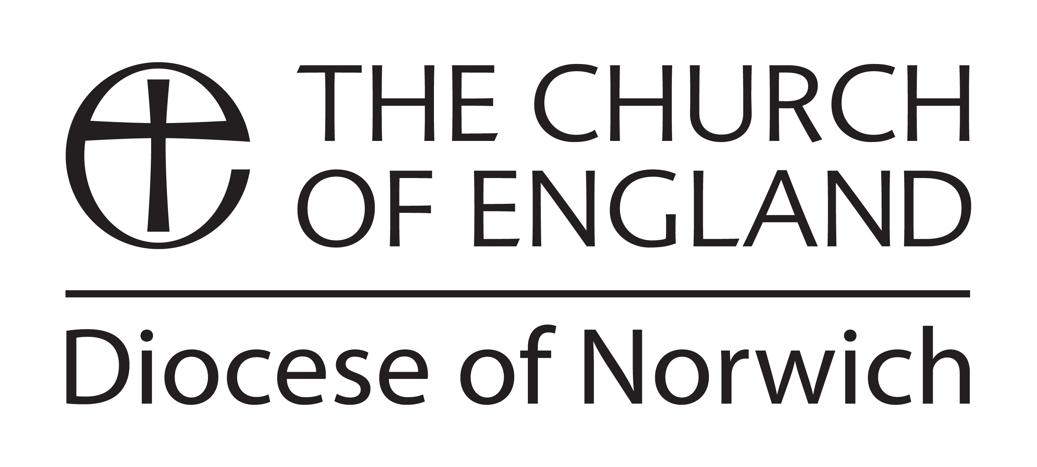
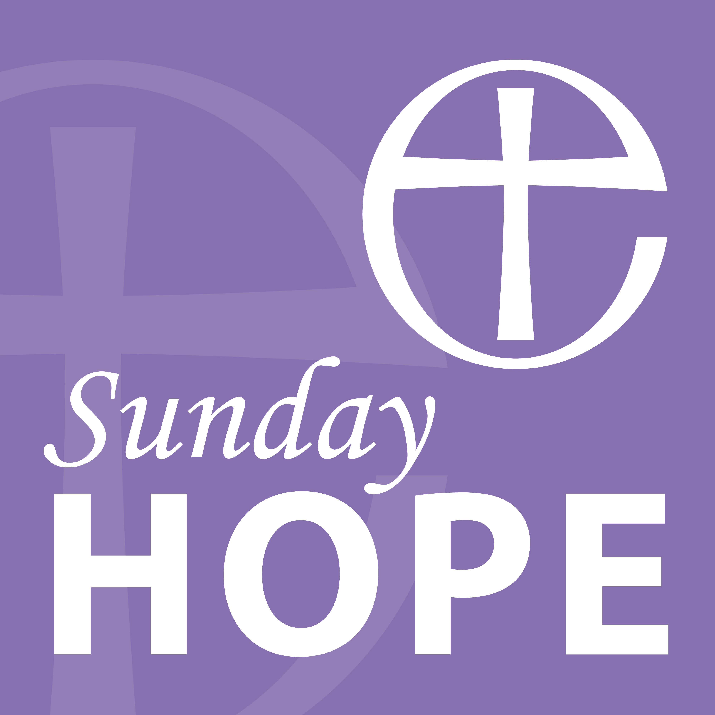

The Diocese of Norwich ‘Sunday Hope’ Podcast

Trinity Sunday – 7 June 2020

Welcome to this service for Trinity Sunday, the day that challenges preachers to explain the mystery of the Trinity of Father, Son and Holy Spirit.

I am the Revd David Hagan-Palmer, Team Vicar of the Bure Valley Churches in the Aylsham & District Team Ministry and I have the pleasure to be speaking to you from my home in the North Norfolk village of Buxton. We will be joined this morning by my wife Julie who will read today’s gospel and by Canon Susanna Gunner who will lead us in prayer.

As we begin you may wish to light a candle to focus your thoughts or perhaps sit in silence as we pause briefly to prepare for our service.

Pause

Let us pray:

Almighty and everlasting God,
you have given us your servants grace,
by the confession of a true faith,
to acknowledge the glory of the eternal Trinity
and in the power of the divine majesty to worship the Unity:
keep us steadfast in this faith,
that we may evermore be defended from all adversities;
through Jesus Christ your Son our Lord,
who is alive and reigns with you,
in the unity of the Holy Spirit,
one God, now and for ever. Amen.

READING

Our reading is from the Gospel of Matthew chapter 28 verses 16-20:

Now the eleven disciples went to Galilee, to the mountain to which Jesus had directed them. When they saw him, they worshipped him; but some doubted. And Jesus came and said to them, ‘All authority in heaven and on earth has been given to me. Go therefore and make disciples of all nations, baptizing them in the name of the Father and of the Son and of the Holy Spirit, and teaching them to obey everything that I have commanded you. And remember, I am with you always, to the end of the age.’

HYMN

Holy, holy, holy, Lord God almighty

HOMILY

In these past months of COVID-19 along with my usual role of Team Vicar I have been involved in a multi-agency group overseeing what is known as the Mortality Pathway - ensuring that, despite the challenges of COVID, the pathway from death to burial or cremation is kept clear and the dignity and care of the deceased as well as the bereaved is maintained throughout.

In this role I suddenly found myself having to build new relationships with the other members of the group, as well as leaders of other faiths and denominations, whom I had never met and still to this day mostly only know through the screen of a computer, on the end of the phone or through a chain of emails.

Developing relationships in this way has certainly been different, no getting together in a meeting room, shaking hands, and creating bonds in the usual way. Yet relationships have been made, trust and respect given and received; and working friendships formed.

I wonder how many other relationships have been formed during this time of COVID? Neighbours speaking with neighbours, communities coming together to help each other. You certainly hope these kinds of caring and supportive relationships continue to exist and even continue to be formed after the response to COVID is over.

Relationships are part of our everyday life – family, friends, neighbours, communities, and work relationships.

At the start of this service I mentioned that today is Trinity Sunday which comes with it the challenge to explain the Holy Trinity.

For me the important thing about the Trinity is that it is not a finite description of God; as God is surely so immense and amazing that God is indescribable? it is more about describing how we experience God in our lives, it is about the relationship we have with God.

The Trinity can help to explain how our relationship with God is experienced in three distinct ways. We relate to God as “above us,” “with us,” and “within us.” In the gospels, the Father is often referred to as God “above us.” Jesus, on the other hand, is called Emmanuel - God “with us.” And the Spirit is identified as God “within us.”

Growing in the knowledge of God then means coming to know God through three expressions of our interaction with the Trinity - how, in God we live, move, and have our being. Of course, we must also keep in mind that we are not talking about a separateness in God, but only in the ways we experience God; how we have a relationship with God. It is not a matter of getting the description right or trying to get an exact definition; it is more about knowing the fullness of our experience of God in these three expressions.

As “God above us,” our Father stands apart from us. He is beyond the mortal limits under which we live. In this relationship we pray and relate to the Father just as Jesus did.

As the Son, we experience God as “with us.” Jesus, Emmanuel, is incarnate in our experience of life, in the very circumstances and human history in which we move. He loves us, accompanies us, shepherds us and is with us to the end of ages. It is Jesus’ saving mission that we seek to serve on earth.

And finally, in our experience of the Holy Spirit, we recognize God as “within us.” As the immanent ground from which we have our being, the Holy Spirit purifies us in our relationship with the Father and moves us to love and serve the purposes of Jesus the son.

As the fullness of the knowledge of God matures in our lives may we worry less about defining God, may we accept through our Faith the immenseness of God, the mystery of God and the indescribable nature of God and let us instead focus upon our relationship with God and sharing that relationship with those we meet.

At these times of COVID more than ever we need to bring hope to the world by letting others know of God’s presence in their lives. Through our actions as Christians and the positive relations we create with others let us show how, through God’s boundless love and desire to have a relationship with us through the Trinity, God is at work in the world – above us, with us and within us.

As you reflect about the Trinity you might like to ponder these questions?

- How might you forge new relationships in the times ahead or strengthen existing ones?

- How do you feel your relationship with God has been during these times – how has your prayer life been?

- Are there some relationships you should reconnect with?

PRAYERS

Let us pray

Trinity of Love
you are our Creator,
parenting us into being,
the holy, dynamic pulse of Life
behind the whole universe.

Trinity of Love
you are the Crucified and Risen One,
Love personified,
the holy, healing ‘God-with-us’
redeeming our world.

Trinity of Love
you are our Comforter,
sustaining, eye-opening Spirit,
the holy current of communication
nudging us daily into encounter.

Holy, holy, holy!
Trinity of love -
we worship you!
Amen

God the Holy Trinity
draw us into the circle of love
between Father, Son and Holy Spirit:
grace us to mirror
in our own relationships
the self-giving which flows between you;
touch with your tenderness
those relationships strained by lockdown,
suffering from separation
or fractured by death;
and bless now and in the days to come
the many new ways of relating
which pandemic has brought to birth.
Amen

Let us pray together as our Saviour taught us:

Our Father, who art in heaven,
hallowed be thy name;
thy kingdom come;
thy will be done;
on earth as it is in heaven.
Give us this day our daily bread.
And forgive us our trespasses,
as we forgive those who trespass against us.
And lead us not into temptation;
but deliver us from evil.
For thine is the kingdom,
the power, and the glory
for ever and ever.
Amen.

HYMN

Christ is made the sure foundation

BLESSING

God the Holy Trinity make you strong in faith and love,
defend you on every side,
and guide you in truth and peace;
and the blessing of God Almighty, the Father, the Son and the Holy Spirit
be with you now and remain with you always. Amen.

