
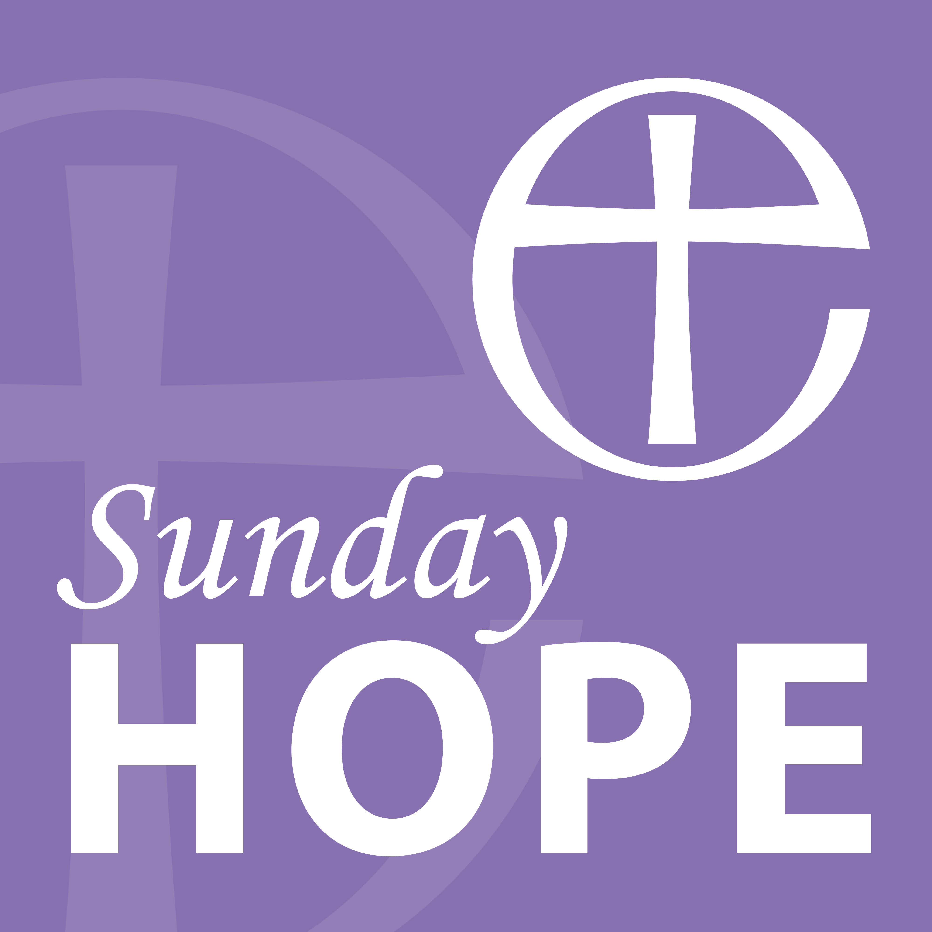

The Diocese of Norwich ‘Sunday Hope’ Podcast

Sunday 28 June 2020

The Revd Canon Julie Boyd, Team Rector for St Faith’s Church, Gaywood

Welcome to Sunday Hope. My name is Julie Boyd. I am the Team Rector for St Faith’s Church in Gaywood and I am speaking to you today from my home in King’s Lynn. You will hear two other voices in this service, my husband, Matthew will be reading from scripture and Canon Susanna Gunner will be leading us in prayer.

We pause for a moment’s quiet as we remember that we are in the presence of God.

Pause

Let us pray

God our Saviour,
look on this wounded world
in pity and in prayer;
hold us fast to your promises of peace
won for us by your Son,
our Saviour Jesus Christ. Amen.

READING

The reading is from Matthew’s Gospel, chapter 10 verses 40-42

⁴⁰ ‘Anyone who welcomes you welcomes me, and anyone who welcomes me welcomes the one who sent me. ⁴¹ Whoever welcomes a prophet as a prophet will receive a prophet’s reward, and whoever welcomes a righteous person as a righteous person will receive a righteous person’s reward. ⁴² And if anyone gives even a cup of cold water to one of these little ones who is my disciple, truly I tell you, that person will certainly not lose their reward.’

HYMN

How Great Thou Art

HOMILY

Lock-down started on March 23rd, just over three months ago. In the weeks leading up to that date, do you remember back then, how things were? We were being encouraged not to touch but social distancing hadn’t really started at that point. We were struggling with not shaking hands, but we could still knock elbows! (Not that I ever did!) Not shaking hands is still challenging but actually once we had that two-metre space around each one of us, it meant that we couldn’t actually reach someone else’s hand anyway. Things changed.

And then when lock-down happened we were asked, for the most part to stay home, to only venture out for essentials and even then, to keep social distance, to create a space into which no one must come.

We have learnt new cultural standards, in a very short period of time. And if like me you have now entered into a social bubble you might be finding it difficult to recondition yourself to allow the select few to come near. So, with all this, what is normal? Surely normal is to embrace, to welcome, to show hospitality and not at arm’s length. Is that not what we all long for, need even?

Catholic priest and author, Henry Nouwen had words to say about hospitality. His words might challenge us today. He defines hospitality as a space around us that we create for others into which they can come, be themselves and discover who they are. We shouldn’t look upon someone else as an interruption but as a call from God to love and serve another. It demands our full attention, it demands that we listen to them, it demands patience, understanding and love.

That space into which the stranger might come and find welcome is no longer a physical space. As we hear these words in a culture of social distance we are reminded that hospitality is, in fact, a condition of the heart. From deep within ourselves we discover the love and respect we owe the people around us. It means that we watch and wait even from a distance, being patient, yielding and respectful.

So how can we learn new ways of offering this attentive hospitality? Perhaps we first need to experience what it is to receive it.

When St Benedict wrote about hospitality in his rule of life for religious communities, he said this about the reception of guests.
“Let all guests who arrive be received like Christ, for He is going to say, “I came as a guest, and you received Me.” And to all let due honour be shown, especially to the domestics of the faith and to pilgrims.”

Have you ever visited a monastery and found that the welcome you received was abundant in generosity and in graciousness? You were being received like Christ. To be received like Christ is to receive honour, but honour that humbles the guest as well as the host.
You might also have noticed that such a welcome in a monastery is often given without coming physically close. A social distance doesn’t mean a cold reception.

This is what Jesus said to his disciples, “He who receives you, receives me; and he who receives me, receives him that sent me.”

I am to receive you as Christ
and you are to receive me as Christ
and when we do, when we have this condition of the heart;
we welcome Christ.

These words of scripture might lead us to ponder our response throughout this time of pandemic.
- Consider the hospitality that has been offered to you, how people have opened up the space around themselves in new ways.
- Consider what has been given from the heart and how we might open up our hearts to others.
- Pray that God will place this ministry upon your heart today.

PRAYERS

Let us pray:

Welcoming Christ
we thank you for those who, in recent months,
have reflected your attentive hospitality,
those who have tended the sick and accompanied the dying,
those who have consoled the bereaved and reached out to the isolated,
those who have fed the hungry and sustained vital services,
those who continue to do all these things.
Fire our imaginations and kindle our love
that in the months to come
we may search for hospitable space in and around us -
expecting to receive you as we receive others,
humble enough also to be received as you.
Amen

Endlessly self-giving God,
we pray for your grace
and for your holy transformation
as we ponder the condition of our hearts:
when they are cold and stony, warm and soften them;
when they are skewed by prejudice, straighten them;
when they are too easily contented, challenge them;
when fear freezes them, locking out love, thaw and reassure them;
when they are anxious and unsure of your presence, enter them.
So may the condition of our hearts mirror yours
and all hostility be turned to hospitality.
Amen

Let us pray together as our Saviour taught us:

Our Father, who art in heaven,
hallowed be thy name;
thy kingdom come;
thy will be done;
on earth as it is in heaven.
Give us this day our daily bread.
And forgive us our trespasses,
as we forgive those who trespass against us.
And lead us not into temptation;
but deliver us from evil.
For thine is the kingdom,
the power, and the glory
for ever and ever.
Amen.

HYMN

O thou who camest from above

BLESSING

The peace of God,
which passes all understanding,
keep your hearts and minds
in the knowledge and love of God,
and of his Son Jesus Christ our Lord;
and the blessing of God almighty,
the Father, the Son, and the Holy Spirit,
be amongst you and all those you love this day and forever more.
Amen.

