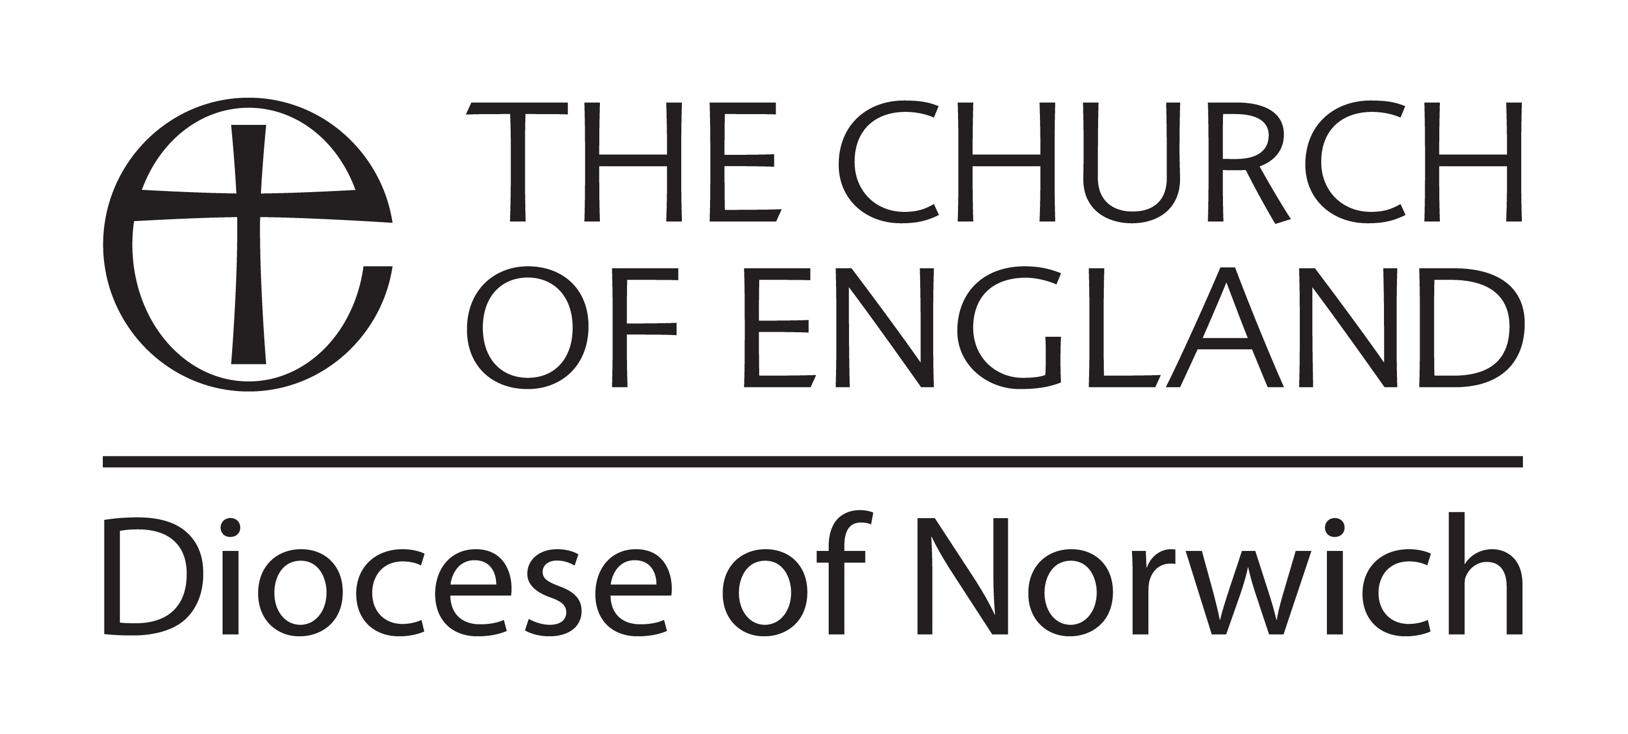
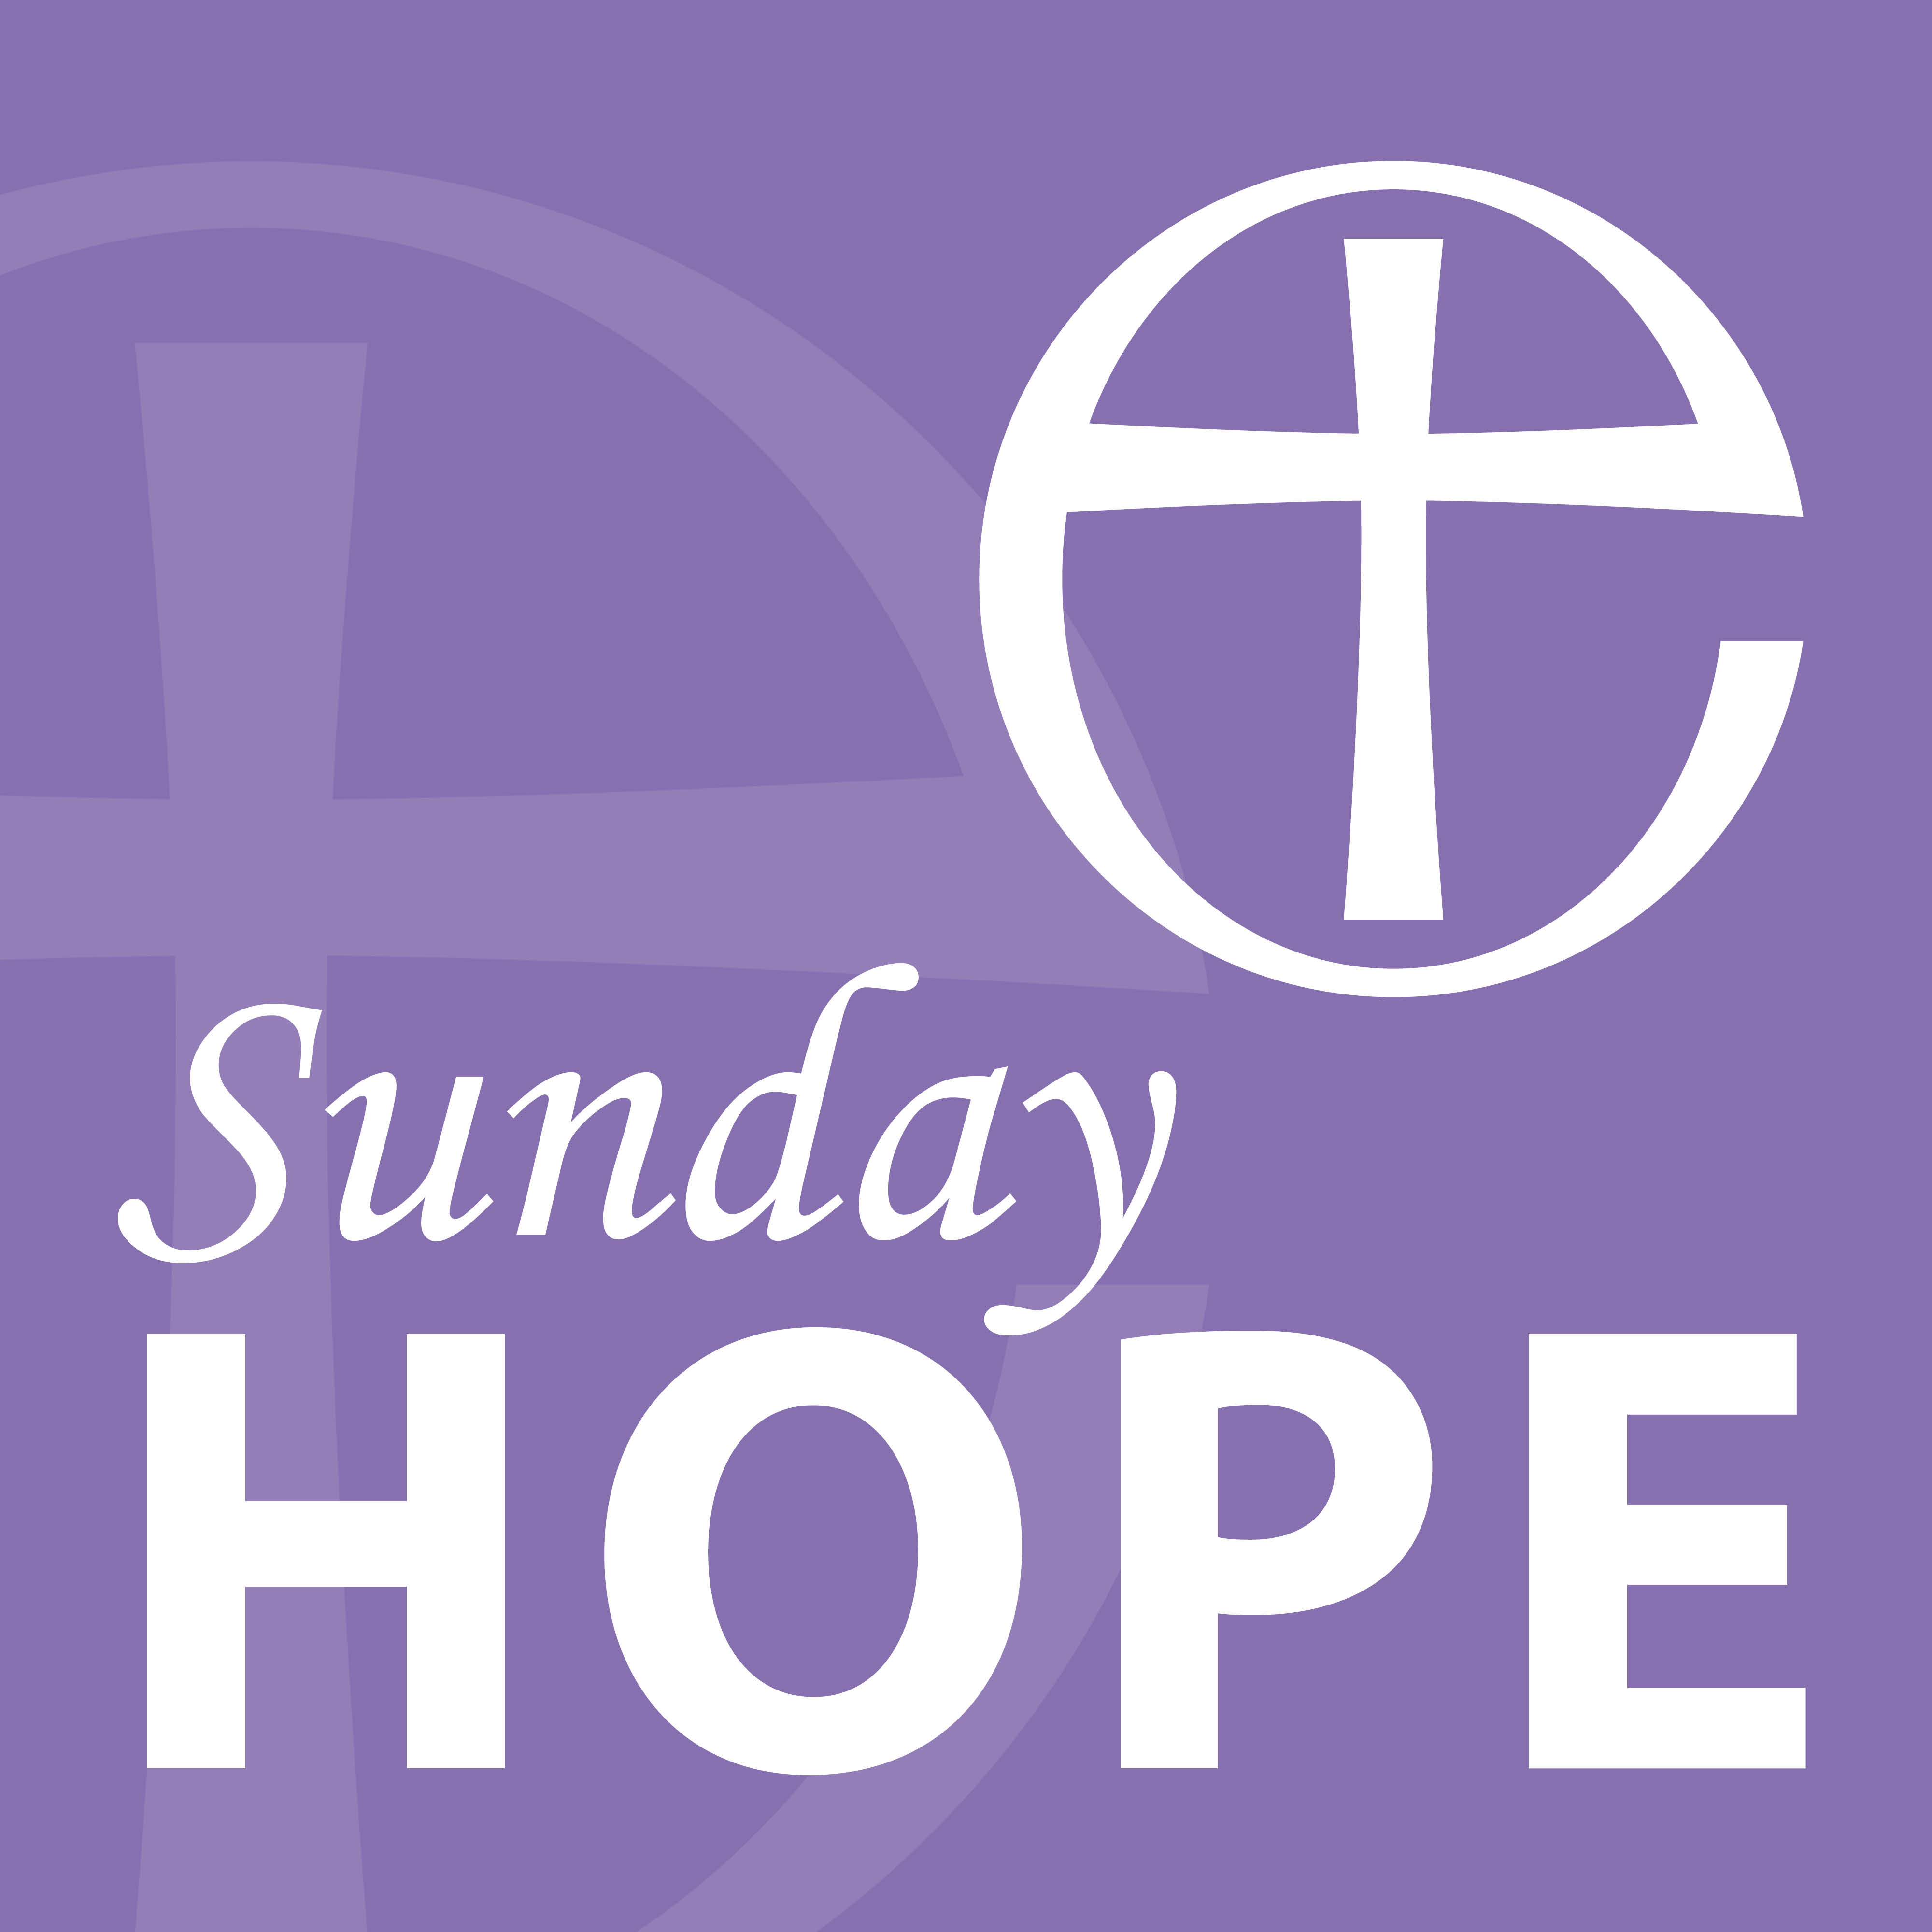

The Diocese of Norwich ‘Sunday Hope’ Podcast

Sunday 14 June 2020

Welcome to this podcast for Sunday 14 June, the First Sunday After Trinity.

I’m the Revd Keith Rengert, Rural Dean of Ingworth & Sparham Deanery and Team Rector of the Reepham & Wensum Valley group of parishes. I also have various chaplaincy roles which include being a chaplain to the East Anglian Air Ambulance and the East of England Ambulance Service. It is these two organisations I shall be particularly focussing on today.
The Gospel Reading will be read by Patrick Peal, CEO of the East Anglian Air Ambulance, which has bases at Cambridge & Norwich Airports’. The prayers will be read by my wife and colleague Revd Helen Rengert.

Before we begin you might like to light a candle and have a moment of silence.

Let us pray…

O God,
the strength of all those who put their trust in you,
mercifully accept our prayers
and, because through the weakness of our mortal nature
we can do no good thing without you,
grant us the help of your grace,
that in the keeping of your commandments
we may please you both in will and deed;
through Jesus Christ your Son our Lord,
who is alive and reigns with you,
in the unity of the Holy Spirit,
one God, now and for ever.
Amen.

READING

Our reading from the Gospel according to Matthew (9:35 – 10:8):

Then Jesus went about all the cities and villages, teaching in their synagogues, and proclaiming the good news of the kingdom, and curing every disease and every sickness. When he saw the crowds, he had compassion for them, because they were harassed and helpless, like sheep without a shepherd. Then he said to his disciples, “The harvest is plentiful, but the labourers are few; therefore ask the Lord of the harvest to send out labourers into his harvest.”

Then Jesus summoned his twelve disciples and gave them authority over unclean spirits, to cast them out, and to cure every disease and every sickness. These are the names of the twelve apostles: first, Simon, also known as Peter, and his brother Andrew; James son of Zebedee, and his brother John; Philip and Bartholomew; Thomas and Matthew the tax collector; James son of Alphaeus, and Thaddaeus; Simon the Cananaean, and Judas Iscariot, the one who betrayed him.

These twelve Jesus sent out with the following instructions: “Go nowhere among the Gentiles, and enter no town of the Samaritans, but go rather to the lost sheep of the house of Israel. As you go, proclaim the good news, ‘The kingdom of heaven has come near.’ Cure the sick, raise the dead, cleanse the lepers, cast out demons. You received without payment; give without payment.

HYMN

Thou Whose Almighty Word

HOMILY

There are two areas that I wish to reflect on from this reading.

The first particularly struck me when I was a fairly new curate in my Title Parish some 10 years ago. I was sent to visit a mother and baby to prepare them for her baby’s baptism a couple of weeks, later which I was to conduct. Upon arrival I was shown into the living room that had a television on the wall the size of a small planet and it was on – loudly.
Lacking in confidence I chickened out of asking for it to be turned off or at least muted whilst we had our discussion. Consequently, it was less a discussion and more a monologue from me about baptism. I was competing and losing to whatever soap opera was being played out on planet TV. I was in and out of the house within 13 minutes. I felt pretty rubbish. I had failed to communicate the significance of Christian baptism and had let her down, God down and my church down. I resolved that in a couple of weeks’ time at the Christening itself (where there would be no TV to compete with) I would make sure she and her guests were left in no doubt about the significance and seriousness of the baptismal rite and act.

The great day came and, as determined as ever to atone for my dismal baptismal preparation, at the appropriate point in the service marked ‘address’ I stepped onto the bottom step of the font so I could be seen and surveyed my congregation. I would like to assure you that I had their full attention, but that wasn’t quite the case.

However, as I looked at them all and drew breath to begin my theological treatise a verse from the Bible popped into my head. A verse we have just heard read to us…

‘When he saw the crowds, he had compassion for them, because they were harassed and helpless, like sheep without a shepherd.’

At that moment my heart melted within me towards these people. They were spared my theological explanation of baptism, instead I found myself acknowledging that church was probably an alien environment for many of them, but that I and God were just delighted that they were here now. I found myself telling them how loved they were by God.

That is the primary message of Christianity, love and hope. We expect and perhaps even believe that God should sort ‘them others’ and maybe also us, ‘out’. Instead he sends his Son to teach us, to love us and ultimately, to die for us, because he loves us all so very much.

Today’s reading is about being sent out to heal and save the ‘lost sheep’. There seems to be so much looking out for number one and everyone for him or herself in our world.

So when I think about those who care for us at our time of deepest need I realised how blessed we are in this country. In times of great distress one phone call to the emergency services brings help, not reluctant help, not begrudging help, but willing and highly skilled help to wherever we are, even to the extent, if necessary, to flying a mobile ICU unit to where we or our loved ones need it to be.

Praise be to God that there are so many in our nation that choose to train as doctors, paramedics, nurses and so many more, and they don’t have to, they choose to.

When this current pandemic is over, and it will one day be over. I hope and pray that this outpouring of gratitude and goodwill to our NHS workers and key workers might continue. Let us not forget the feelings we have towards them now when the business of life once again tries to get in the way of such niceties.

So if you see an ambulance crew driving past smile or wave at them (a bit harder to do for the air ambulance I grant you, but you can wave anyway). They have been there for us, let’s continue to be there for them, for when they step in to heal and save, they are stepping right into our Lord’s own shoes.

Amen.

SOME THOUGHTS FOR REFLECTION

Reflect upon that verse from Matthew I mentioned:

‘When he saw the crowds, he had compassion for them, because they were harassed and helpless, like sheep without a shepherd.’

- Where can you show that same love and compassion in your community?

- Remember to say ‘thank you’ to those who help us, even if they are ‘just doing their job’.

PRAYERS

Father God, source of all compassion, pour out your love on those who need it most today. Those who are overwhelmed with sadness, those who are distressed, those who are at the end of their tether, those who can’t cope anymore, those who are recovering from addictions, those who are lost for words, those who are so angry that hate is all they feel and those known only to you. Lord have mercy, Lord have mercy

Jesus Christ, source of all compassion, pour out your healing on those who need it most today. We call to mind in our hearts those we know and those known only to you. (silence)

Holy Spirit, source of all compassion, pour out your strength on those who need it most today. We pray for our frontline key workers, NHS staff, Ambulance Staff and those working at the Air Ambulance Charity. We especially pray for those who are tired from long shifts, those who also have young families, those who have other dependants to care for, those who are overwhelmed with sadness and those known only to you. Christ have mercy, Christ have mercy

Triune God, source of all compassion, pour out your blessings on those who need You most today. Give us resources we need to bring love, joy, peace, patience, goodness, faithfulness gentleness and self-control to the world. So that we too, as your disciples, can be true to our vocation to be Your hands and feet here and now. Lord have mercy, Lord have mercy

Let us pray together as our Saviour taught us:

Our Father, who art in heaven,
hallowed be thy name;
thy kingdom come;
thy will be done;
on earth as it is in heaven.
Give us this day our daily bread.
And forgive us our trespasses,
as we forgive those who trespass against us.
And lead us not into temptation;
but deliver us from evil.
For thine is the kingdom,
the power, and the glory
for ever and ever.
Amen.

HYMN

The King of Love My Shepherd Is

BLESSING

The peace of God,
which passes all understanding,
keep your hearts and minds
in the knowledge and love of God,
and of his Son Jesus Christ our Lord;
and the blessing of God almighty,
the Father, the Son, and the Holy Spirit,
be among you and remain with you always.
Amen.

