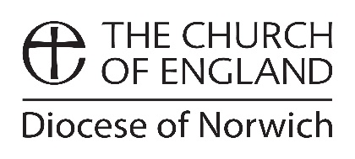
Data Protection Form

All PCC members or those with a benefice or deanery role must complete this form online at www.dioceseofnorwich.org/data or below. Clergy, Readers, AWAs and Churchwardens are not required to complete a form unless they hold another role which does require a form to be completed.

The Bishop has asked that the Diocese maintains a central record of all PCC members so that we can fulfil our purpose to serve and support the mission and ministry of every parish. As a member of a Parochial Church Council you are also a charity trustee, as all PCCs are charities, and we have a duty to communicate essential information with you and to support you in your role.

This form only needs to be completed once by each individual (not annually) and enables you to confirm your contact details and role. Additionally, it enables you to give consent for how we share your personal data if you wish us to. Please complete as fully as possible. Thank you.

Your name

Title (Mr/Mrs/Miss...): Christian name:

Known as (if relevant): Surname:

Your role

Parish and/or church:

Your role (e.g. Secretary, PCC member, etc.):

Role start date: Role end date (if set):

If you are replacing someone in a role, who are you replacing?

(Please write on the back of this form any additional roles or information which is relevant.)

Your contact details

Address line 1: Primary telephone no:

Address line 2: Secondary telephone no:

Address line 3:

Town/City: Postcode:

Email address:

Your consent

If you are happy for the Diocese to share your information publicly (e.g. on the Diocesan website), please tick the relevant boxes below to indicate consent. I am happy for the Diocese to share:
my name and role my primary phone no. my email address
my postal address my secondary phone no.

Please ensure this form is signed below

Your signature: Date:

Countersigned: Date:

(This form must be countersigned by either the Incumbent, a Churchwarden or the PCC Secretary.)

Please return to: data@dioceseofnorwich.org or the Data Administrator, Diocesan House,
109 Dereham Road, Easton, Norwich, NR9 5ES. For any enquires please call 01603 882322.

You can view our Privacy Policy at any time at www.dioceseofnorwich.org/about/contact/privacy-policy

Norwich Diocesan Board of Finance Ltd. A Company Limited by Guarantee. Registered in England No. 88175. Charity Registration No. 249318

