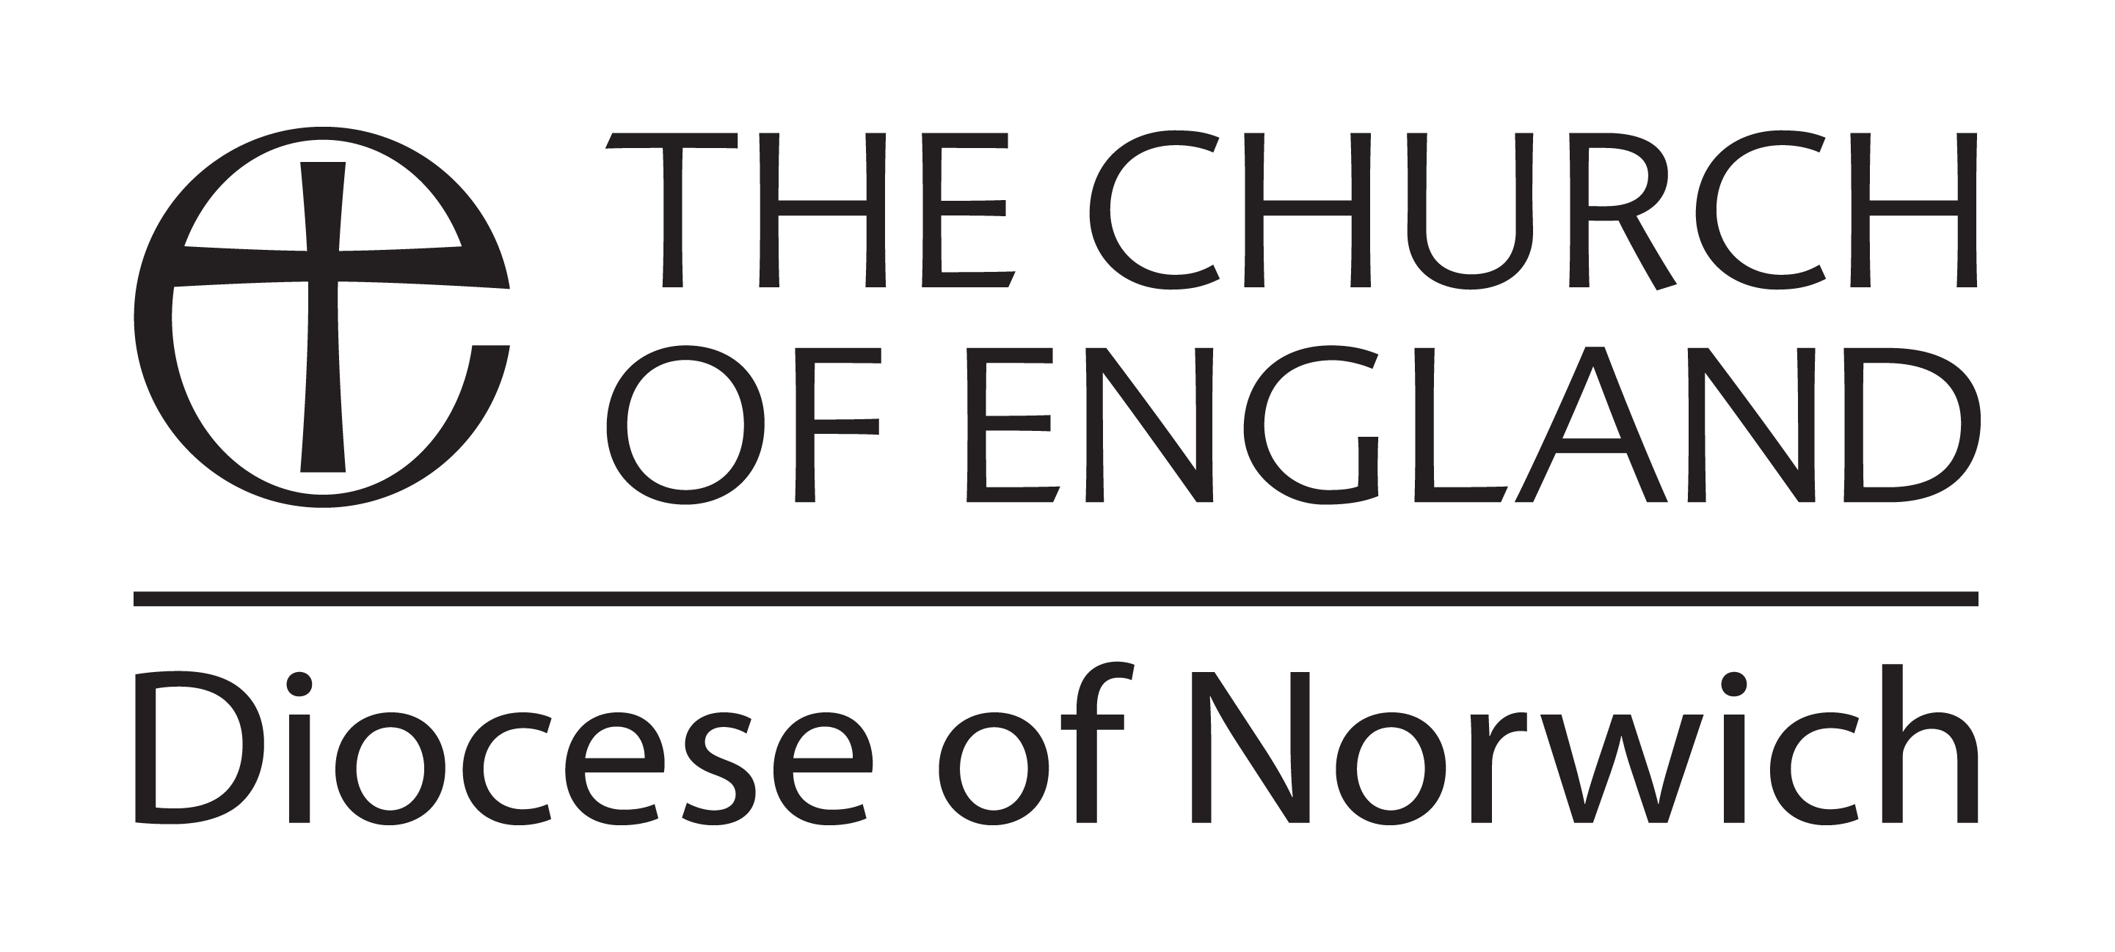
Sharing Good News Fund

Committed to Growth
Grants to encourage mission in local communities

As you put into action your Growth Plan as part of the Committed to Growth process within your parish, there may be an idea which cannot get off the ground for lack of some initial funding. The Sharing Good News Fund is designed to get things started.

- Parishes, benefices, deaneries and Churches Together groups can all apply
- Up to £600 is available under this scheme (and limited to a maximum of 75% of the cost for the project) for projects that demonstrate local commitment; it is remarkable what a relatively small sum can help achieve, especially if it also helps to unlock other resources.
- The key criterion is that your proposal should help you express more effectively God’s mission in your community
- The project should be part of the mission strategy contained in your Committed to Growth plan.

What could you do with a little helping hand?

All parishes are encouraged to develop Growth Plans and to review these on a regular basis. Once your church has agreed its targets, this Sharing Good News Fund may help to turn your plans into action. Together with the simple application form, we ask that you send us a copy of your Growth Plan, showing that the project for which you are seeking funds is part of your broader strategy.

Your grant can be a significant amount to help start some new initiative, assist with a one-off project or contribute to something larger. It might, for example, help a parish, benefice or other group to ….

- Run a children’s club during school holidays
- Buy equipment for a toddlers’ group
- Produce good quality leaflets, signs, displays or prayer aids for people who visit your church building
- Buy materials to offer ‘Godly Play’ in your local school
- Run a mission weekend, musical or arts event or other special activity to draw in those with whom you have contact in your community
- Run Alpha, Emmaus or Credo courses
- Provide special gift parcels for housebound or other needy people
- Distribute gospels or other literature to homes in your community
- Set up a church-run community news-leaflet or similar
- Buy a piece of equipment that you will go on using as a resource for mission

As you plan…
- Find out what ideas others in your area have: it may be that by working with others (e.g. neighbouring parishes) you would all end up doing something better.
- Be sure that you have thought through issues like insurance and DBS requirements; if anybody is to be employed (even if short term or for few hours) make sure you act according to the law.
- Ask for advice if you need it from your Bishop, Archdeacon or the Diocesan Secretary.

And finally…
- If you are awarded a grant you will need to send us a brief report (please send via the Diocesan Secretary within 6 months), letting us know how your mission project went; is it achieving what you hoped? To encourage others, we may feature your project in Diocesan publications or on the Diocesan website or even in the local media. If appropriate, please include photographs in your report.
- Only one grant will be awarded per applicant within a twelve month period.

Sharing Good News Fund
Application form

- Applicant (Parish/Benefice/Deanery/other)

- Date of agreement by PCC:

- Total project cost:
£

- Total requested towards project
£

5. Where will the difference between these two figures come from?

6. What do you want to do and how will you do it? (The Project)

7. What will be the result? (How will you evidence this)

8. Please give a breakdown of the costs, including any other sources of funding.
Feel free to attach any supporting information. (Please attach a full budget with both
income and expenditure)

9. Have you applied for a Sharing Good News grant before?
Yes / No

If yes, when?

10. Please attach a copy of your Committed to Growth Plan, highlighting how this project will help fulfill your plans.

Proposer’s signature Date

Name and Position

Address

Telephone

Email address

Signature of incumbent Date

Payments are made by direct credit (BACS). In order to arrange direct credit to your bank account, please advise of your:

Bank Account Name: (e.g. Anytown PCC)

Sort Code:

Account number

Email address (for electronic remittance advice)

Please return this form to:

The Diocesan Secretary, Diocesan House, 109 Dereham Road, Easton, Norwich NR9 5ES

E-mail: joanna.church@dioceseofnorwich.org

